DESIGN AND IMPLEMENTATION OF AN INTELLIGENT CONTROL SYSTEM FOR
A HYBRID INVERTER TRANSFORMER

BY

AMUSAN OLUWAFEYIBUNMI OLUWATETISIMI
(2020/9433)

BELLS UNIVERSITY OF TECHNOLOGY, OTA NIGERIA

JULY, 2025

DESIGN AND IMPLEMENTATION OF AN INTELLIGENT CONTROL SYSTEM
FOR A HYBRID INVERTER TRANSFORMER

BY

AMUSAN OLUWAFEYIBUNMI OLUWATETISIMI
(2020/9433)

A Project Submitted to The Department of Mechatronics Engineering, College of
Engineering, Bells University of Technology, Ota, Ogun State Nigeria. In Partial
Fulfilment of The Requirements for the Award of Bachelor of Engineering in
Mechatronics Engineering

JULY, 2025

CERTIFICATION
This is to certify that this project titled “DESIGN AND IMPLEMENTATION OF AN INTELLIGENT CONTROL SYSTEM FOR A HYBRID INVERTER TRANSFORMER” is an
original research work carried out by AMUSAN OLUWAFEYIBUNMI OLUWATETISIMI of Matric Number, 2020/9433in the Department of Mechatronics Engineering, College of Engineering, Bells University of Technology, under my supervision. I have examined.

___________________ _______________________
Engr. Johnson O. Abiola Date
(Project Supervisor)

________________________ _____________________
Dr. Chinedu Ezugwu Date
(Head of Department)

DECLARATION

I, AMUSAN OLUWAFEYIBUNMI OLUWATETISIMI (2020/9433) hereby declare that this research project was carried out by me under the supervision of Engr. Johnson O. Abiola of the Department of Mechatronics Engineering, Bells University of Technology, Ota, Ogun State, Nigeria. I attest that the project has not been presented either wholly or partially for the award of any degree. All sources of data and used in this project are acknowledged.
…………….………………………
AMUSAN OLUWAFEYIBUNMI
DATE: ………………………………

ACKNOWLEDGEMENT
I would like to express my heartfelt gratitude to all those who have contributed to the successful completion of this project on the "Design and Implementation of an Intelligent Control System for a Hybrid Inverter Transformer."
First and foremost, I extend my deepest appreciation to my supervisors, Engr. Johnson O. Abiola, for his invaluable guidance, expertise, and unwavering support throughout the course of this research. Their insightful feedback and encouragement were instrumental in shaping the direction and quality of this work.
I am also grateful to Dr. Chinedu A. Ezugwu, Head of the Department of Mechatronics Engineering at Bells University of Technology, for providing an enabling academic environment and the necessary resources to carry out this project.
My sincere thanks go to the faculty and staff of the Department of Mechatronics Engineering, College of Engineering, Bells University of Technology, Ota, Nigeria, for their academic support and encouragement. Their contributions to my learning experience have been invaluable.
I would also like to acknowledge my family and friends for their constant encouragement, patience, and moral support, which kept me motivated throughout this endeavor. Special thanks to my colleagues and peers for their collaborative spirit and for sharing ideas that enriched this project.
Finally, I am grateful to the Almighty for the strength, wisdom, and opportunity to undertake and complete this research. This project would not have been possible without the collective support and contributions of everyone involved.

ABSTRACT
Emergent requirements of integration of renewable energy have fostered the creation multifaceted hybrids; Hybrid Inverter Transformers (HITs). Such issues as voltage variation, cooling and load sharing continue to be a problem however, and intelligent control is important. This project comes up with an intelligent control system of a hybrid inverter transformer to improve energy management, efficiency and reliability of the solar battery grid hybrid systems.The applied methodology is a 3-layered (sensing, control, actuation) architecture with 3.5kW inverter, 1kW solar, 48V Li-ion battery and sensors. A combination of PID control, dynamic load sharing, and a Battery Management System (BMS) that focuses more on solar power and easy transition into the grid, is incorporated in firmware (C++/Arduino IDE).The results are in 93.8 percent efficiency, 0.5 s switching response (5X faster than the static systems), 49 percent reduced power losses, and voltage regulated stable at (1.3 percent). Adaptive algorithms ensured long life of battery as it eliminated deep discharging.The latter system has a high chance of overcoming HIT obstacles, and it provides a solution to the problems that is long term regarding residential/smallscale industrial application. The upcoming developments cover IoT and scalability. This develops new technologies in the smart grid and clean energy control.
Word Count: 204

TABLE OF CONTENTS
CERTIFICATION iii
DECLARATION iv
ACKNOWLEDGEMENT v
ABSTRACT vi
TABLE OF CONTENTS vii
LIST OF FIGURES xii
LIST OF PLATES xiii
LIST OF TABLES xv
LIST OF ABBREVIATIONS xvi
CHAPTER ONE 1

INTRODUCTION 1
1.1 Background of the Study 1
1.2 Statement of the Problem 4
1.3 Aim and Objective of The Study 7
1.4 Scope of the Study 8
CHAPTER TWO 12

LITERATURE REVIEW 12
2.1 Overview of Literature 12

2.2 Hybrid Power Systems 13
2.2.1 Components of Hybrid Power System 13
2.2.2 Challenges in Hybrid Power System 16
2.2.3 The Role of Intelligent Control Systems 17
2.3 Role of Inverter Transformers in Hybrid Systems 17
2.3.1 Functions of Inverter Transformers 18
2.3.2 Challenges with Traditional Inverter Transformers 18
2.3.3 Advancements in Intelligent Control for Inverter Transformers 19
2.4 Intelligent Control Systems: Concepts and Applications 19
2.4.1 Concepts of Intelligent Control Systems 20
2.4.2 Applications in Hybrid Inverter Transformers 20
2.4.3 Current Challenges and Research Gaps 21
2.5 Algorithmic Approaches to Intelligent Energy Management 21
2.5.1 Key Algorithmic Techniques 22
2.5.2 Applications in Hybrid Inverter Transformers 23
2.6 Sensor Integration and Real-Time Monitoring 24
2.6.1 Role of Sensors in Hybrid Systems 24
2.6.2 Real-Time Monitoring and Its Benefits 25
2.7 Battery Management in Hybrid Systems 26

2.7.1 Key Aspects of Battery Management 26
2.7.2 Battery Management System (BMS) Technologies 27
2.8 User Interface Design for Energy Systems 29
2.8.1 Key Considerations in User Interface Design 29
2.8.2 Challenges in User Interface Design for Hybrid Systems 30
2.9 Recent Advances in Hybrid Inverter Control Systems 32
2.10 Key Metrics for Efficiency Evaluation 33
CHAPTER THREE 37
METHODOLOGY 37
3.1 System Architecture 37
3.1.1 Hardware Components 39
3.1.2 Software Components 49
3.2 Control Algorithm Design 51
3.2.1 Power Management Strategy 51
3.3 System Implementation 52
3.3.1 Hardware Interfacing 52
3.3.2 Software Development 56
3.3.3 Integration and Testing 56
3.3.4 System Architecture Description 56

3.4 Hardware Components and Integration 58
3.4.1 Power Sources 58
3.4.2 Hybrid Inverter Unit 59
3.3.5 Control and Monitoring System 59
3.3.6 Data Flow and Communication 60
3.3.7 Load Interface 61
3.5 Hardware Components and Integration 61
3.5.1 Power Sources and Inverter 62
3.5.2 Hardware Integration 65
3.5.3 Sensor and Monitoring System 65
3.5.4 Communication Interface 74
3.6 Control Algorithm Development 78
3.6.1 PID Controller Design 78
3.6.2 Dynamic Load Balancing Logic 79
3.6.3 Battery Management System (BMS) 82
3.7 Software Implementation 85
3.7.1 Firmware Development 85
3.7.2 User Interface Design 89
3.7.3 System Testing and Performance Evaluation. 92
CHAPTER FOUR 93
RESULTS AND DISCUSSION 93
4.1 Overview of Result 93
4.2 Recorded Data Summary 93
4.3 System Load Calculation 101
4.4 Battery Discharge Analysis 101
4.5 Power Factor Determination 101
4.6 Anomalous Inverter Frequency 102
4.7 Solar Input Behavior 102
4.8 System Response Delays 103
4.9 Ratings, Analysis and Calculations 103
4.10 Summary Table 106
CHAPTER FIVE 107
CONCLUSION AND RECOMMENDATIONS 107
5.1 Conclusion 107
5.2 Recommendations 107
REFERENCEES 109

LIST OF FIGURES

Figures Page
Figure 2.1. Hybrid Power System 14
Figure 3.1. Intelligent Hybrid Inverter Transformer Control Block Diagram 38
Figure 3.2. Inverter Transformer 40
Figure 3.3. Solar Panel Array 41
Figure 3.4. Lithium Battery 44
Figure 3.6. Current Sensor 48
Figure 3.7. Arduino IDE 50
Figure 3.8. Block Diagram of the Intelligent Control System 53
LIST OF PLATES

Plates Page

Plate 4.1 Voltage from the panel 97

Plate 4.2 Battery Health 97
Plate 4.4 Incoming Frequency 97
Plate 4.5 Voltage from the grid 97

LIST OF TABLES

Tables Page
Table 3.1 Parameter and Specification of Sensor and Monitoring System 42
Table 3.2 Typical Specifications of Temperature Sensor 44
Table 3.3 Typical Specifications of Power Motor 46
Table 3.4 System Integration Summary 48
Table 3.5 Wireless Communication Modules and Examples 50
Table 3.6 Decision-Making Conditions 52
Table 3.7 Battery Safety Summary 54
Table 3.8 Programming Language and Environment 58
Table 3.9 Firmware Summary 59
Table 4.1 Parameters Measured During System's Operation 61

LIST OF ABBREVIATIONS
EMS Energy Management System
BMS Battery Management System
HITS Hybrid Inverter System
CAN Controller Area Network
DOD Depth of Discharge
DSP Digital Signal Processor

CHAPTER ONE
INTRODUCTION

1.1 Background of the Study
The speedy increase in renewable strength technologies and the transition closer to extra sustainable power structures has brought about a growing demand for efficient, reliable, and adaptive electricity conversion technology. One of the key improvements on this region is the development of hybrid inverter transformers (HITs)(IEEE)Transactions on Power Electronics (2018)), which combine each electricity conversion and voltage transformation features in a single compact unit. These systems are especially vital in packages related to renewable strength assets which include sun, wind, and battery storage, wherein efficient integration with the electric grid is important.
Hybrid inverter transformers function as essential components in energy conversion systems by no longer only stepping up or stepping down voltage degrees but additionally allowing direct (DC) to alternating (AC) conversion (Electronics (Switzerland) (2019)). This makes them a critical part of cutting-edge strength structures, where they facilitate the seamless operation of renewable power assets along the electric grid. By enabling the mixing of renewable power assets into the grid, they help stabilize power float, improve system performance, and reduce losses, for that reason assisting the wider goals of sustainability and grid resilience.
However, no matter the benefits, the operation of hybrid inverter transformers is fraught with challenges. One of the number one concerns is preserving voltage and frequency stability. Hybrid inverters, due to their switching nature and the nonlinear conduct of electricity electronics (Procedial- Social and Behavioral Science (1999)), can introduce harmonics, voltage fluctuations, and transients that may degrade the strength best and have an effect on the operation of sensitive system.
1

Additionally, handling the thermal load generated with the aid of the energy conversion processes is another extensive assignment. Heat dissipation is vital to making sure the sturdiness and reliability of the gadget, as immoderate warmness can result in untimely failure of components.
Furthermore, reaching proper load balancing between the inverter and transformer components is essential for maintaining gadget efficiency. An imbalance in load sharing can cause overloading, higher losses, and potentially reason device failure. Given those demanding situations, sensible manipulate structures have end up important in optimizing the operation of hybrid inverter transformers.
Intelligent manipulate systems leverage advanced algorithms, actual-time data processing, and system mastering strategies to reveal and modify machine parameters dynamically. By incorporating functions which include fault detection, load forecasting, and predictive renovation, these structures can adapt to converting situations, mitigate risks, and beautify the overall performance of hybrid inverter transformers. Such structures can analyze huge volumes of data in actual time, enabling them to make choices that optimize strength conversion, improve energy, and reduce downtime. Fault detection and diagnosis, for example, are essential in identifying early symptoms of device failure, allowing for preventative preservation and minimizing the danger of pricey upkeep or gadget outages.
Moreover, wise management systems can control electricity glides more successfully by ways of ensuring gold standard switching strategies for each inverter and transformer component. This is particularly beneficial in hybrid strength structures, in which the varying nature of renewable energy generation— along with fluctuating sun or wind energy calls for adaptive manipulation strategies to preserve system stability and overall performance. Recent advancements in control technologies, such as Model Predictive Control (MPC), Fuzzy Logic Control, and Artificial Neural Networks (ANN) (ACM Computing Surveys (2023)), have shown excellent promise in improving the performance of hybrid inverter transformers. Model Predictive Control, as an instance, permits for predictive optimization of manipulate movements by way of forecasting the gadget's conduct based totally on a mathematical version, whilst Fuzzy Logic Control is effective in handling the uncertainties and nonlinearities inherent in hybrid structures. Artificial Neural Networks, alternatively, have the functionality to learn from historical records and make real-time changes to enhance efficiency and save you faults.
The integration of hybrid inverter transformers with smart grid technology is likewise a critical location of research. Smart grids, which use superior verbal exchange protocols and sensors to reveal and control power flows, can notably enjoy the incorporation of clever manage structures. By permitting real-time communication between the hybrid inverter transformer and other components of the grid, shrewd control structures can enhance grid stability, lessen energy losses, and ensure that strength distribution is more aware of real-time demand fluctuations.
This undertaking objectives to design and implement a shrewd control gadget for a hybrid inverter transformer. The aim is to expand an adaptive manage algorithm which can display and optimize the operation of the gadget, making sure green power conversion and minimizing the risks of screw ups. The device will even incorporate fault detection mechanisms and predictive protection capabilities, taking into consideration early identity of problems and minimizing downtime. By integrating those functions with smart grid technologies (Renewable and Sustainable Energy Reviews (2016)), the task intends to enhance the overall performance, reliability, and efficiency of hybrid inverter transformers, contributing to the ongoing efforts to modernize energy systems and enhance strength
sustainability.
In end, the history has a look at highlights the crucial position of smart manage structures in overcoming the operational demanding situations faced through hybrid inverter transformers. With the increasing reliance on renewable energy and the integration of smart grid technologies, the want for strong, adaptive, and efficient manipulate strategies is more urgent than ever. By growing and imposing shrewd manage structures for hybrid inverter transformers, this challenge aims to enhance power conversion performance, enhance machine reliability, and facilitate the smooth integration of renewable electricity into the grid, in the end contributing to extra sustainable and resilient electricity infrastructure.

1.2 Statement of the Problem
As renewable electricity assets like solar keep to play an increasing number of pivotal functions in hybrid energy structures, the conventional technique to coping with strength thru fixed settings in inverter transformers is turning into increasingly insufficient. Hybrid energy systems regularly depend upon static manage algorithms, in which the flow of energy from a couple of assets, along with the grid, renewable electricity, and battery storage, is governed by means of predefined parameters that don't account for realtime fluctuations or changes in situations. This static method can lead to lots of challenges that degrade device overall performance, such as power losses, gadget inefficiencies, unreliable power supply, and a normal discount within the lifespan of battery storage gadgets. These issues are especially pronounced throughout top call for durations, when load necessities spike, or while renewable electricity sources are intermittent or unavailable.
The heart of the problem lies inside the lack of ability of traditional inverter systems to evolve to these fluctuations in energy generation and consumption. When renewable sources, which includes solar or wind, are producing strength under the expected levels, or while call for spikes all at once, a fixed machine fails to respond dynamically to those modifications. The result of such boundaries is not only a less green use of the available electricity but additionally a greater dependency on backup grid energy or auxiliary systems, that can boom operational costs and further stress device reliability. Moreover, these inefficiencies often bring about suboptimal fee and discharge cycles for batteries, that may purpose them to become worse greater speedy, reducing their normal effectiveness and main to extra common replacements.
An intelligent manage gadget gives an option to these demanding situations by allowing a hybrid inverter transformer to make actual-time selections primarily based on contemporary conditions. This system could be able to dynamically allocate power from distinctive sources in the maximum most reliable way, making sure that energy is used efficaciously, that batteries are charged and discharged according to firstclass practices, and that the grid or different backup assets are simplest used when simply important. By the usage of actual-time information from smart meters, weather forecasts, load predictions, and electricity great tracking, the gadget can expect strength shortages or surpluses and adjust the flow of power thus. For example, if the device detects that the solar output is possibly to fall under call for in the coming hours, it may modify its settings to increase the charging of batteries or draw from the grid as had to stability the load. Conversely, if there is an extra of renewable energy, it could prioritize charging the batteries to shop that electricity for later use.
This clever manage mechanism could no longer only enhance energy efficiency via lowering waste however also enhance the reliability of the complete system. The capacity to respond quickly to adjustments in demand or deliver ensures that strength outages or dips in power availability are minimized. Furthermore, such a gadget would permit for extra advanced battery management protocols, optimizing charge and discharge cycles based totally on real-time elements which include battery health, energy call for, and to be had renewable strength. This might expand battery lifestyles, reduce the want for renovation, and lower general gadget charges in the long term.
The development of such a machine requires a complicated integration of hardware and software program. On the hardware facet, the inverter transformer might need to be prepared with sensors and communication interfaces able to accumulate Realtime statistics on voltage, present day, temperature, and other operational parameters. On the software program side, superior algorithms would be needed to method these records, make predictive exams, and regulate the gadget's settings.
Machine getting to know strategies could also be hired to continuously enhance the accuracy of these predictions over time, mastering past behavior to make higher informed decisions.
In conclusion, a sensible management gadget for hybrid inverter transformers is not only a suitable characteristic but a need for the future of hybrid strength structures (ET Power Electronics (2023)).
With the growing penetration of renewable electricity resources, the capacity to dynamically manage power flows, optimize strength storage, and beautify system reliability can be important for making sure that these systems perform at their maximum performance and offer dependable, price-effective electricity within the face of fluctuating supply and call for. The development of advanced manage algorithms, coupled with real-time monitoring and adaptive control protocols, will be the key to unlocking the full capacity of hybrid electricity systems and ensuring that renewable energy may be included seamlessly into the grid.

1.3 Aim and Objective of The Study
The aim of this project is to design and implement an intelligent control system for a hybrid inverter transformer to optimize energy management, enhance operational efficiency, and ensure a reliable power supply from solar and battery sources. The system will be capable of dynamically managing power flow to balance load demand, prioritize renewable energy sources, and protect the system from overloads and energy losses. The specific objectives are;
- Design a control system to integrate solar and battery storage for continuous power with priority on renewable sources to reduce battery dependency.
- Integrate sensors to monitor system parameters (voltage, current, power) for adaptive, safe operation under varying conditions.
- Evaluate efficiency, load balancing, and response time under different conditions to confirm reliability and efficiency.
- Develop a user-friendly interface to show system status, battery levels, to allow easy monitoring and control.

1.4 Scope of the Study
The scope of this study is centered around the layout, improvement, and implementation of a sensible manage device geared toward enhancing the operation and efficiency of hybrid inverter transformers in electricity systems that integrate multiple power assets, together with renewable strength (sun), grid electricity, and power storage structures (batteries). The attention will be on creating an adaptive manage system that can dynamically optimize electricity control, improve power efficiency, and make sure machine reliability in response to real-time fluctuations in power call for and availability. a) System Design and Architecture
The study will discover the overall layout of a hybrid inverter transformer device geared up with a shrewd manage device. This includes the selection of appropriate hardware additives, including inverters, transformers, smart meters, sensors, and verbal exchange interfaces, required to collect real-time operational statistics. The architecture of the gadget will integrate power resources, garage, and cargo management while ensuring seamless coordination among renewable energy assets and grid energy. b) Control Algorithm Development
A key issue of this examine is the improvement of advanced manage algorithms able to managing the glide of power from a couple of electricity sources. The device will be designed to:
- Dynamically reply to fluctuations in renewable strength era (solar, wind) and modify energy
distribution as a result.
- Optimize the charging and discharging cycles of energy garage systems iii. Ensure that grid energy is utilized best whilst necessary to satisfy load demand or make amends for fluctuations in renewable technology.
iv. Provide actual-time choice-making that adapts to changing environmental and operational conditions.
- Energy Management System (EMS) Integration
The look at will study the combination of an intelligent Energy Management System (EMS) capable of actual-time tracking and statistics analysis. The EMS will use facts from smart meters, weather forecasts, and load predictions to optimize energy flow. The system can be liable for managing and balancing electricity distribution in a way that maximizes the usage of renewable power and minimizes reliance on grid energy.
- Battery Management and Optimization
One of the crucial areas of awareness might be the optimization of battery fee and discharge protocols. The intelligent control gadget will encompass a sophisticated Battery Management System
(BMS) that video display units the kingdom-of-fee (SOC), health, and performance of the batteries. This will permit for real-time adjustment to charging strategies based totally at the, to be had electricity from renewable resources and grid, making sure that batteries are charged in a way that prolongs their operational existence and optimizes strength storage ability.
- Real-Time Monitoring and Data Acquisition
The look at will encompass the design and implementation of a real-time monitoring gadget that captures facts on energy era, intake, and battery repute. This data will be essential for the shrewd manipulate system to make knowledgeable decisions. The have a look at will deal with how to acquire, transmit, and procedure this information thru a significant manage unit, the usage of wireless or stressed conversation protocols that permit for non-stop tracking and modifications in the system. f) Simulation and Modeling
A huge part of the observer will cognizance on simulating the hybrid strength gadget with the included intelligent manipulate gadget earlier than actual implementation. Using simulation software program (along with MATLAB, Simulink, or others), the performance of the device may be modeled underneath numerous scenarios, inclusive of fluctuations in renewable power availability, load versions, and battery performance. The simulation results could be used to satisfactory-tune the manage algorithms and make certain the device can perform successfully under specific situations. g) Prototype Implementation and Testing
Based at the machine design and manipulate algorithm, an operating prototype of the shrewd control machine will be developed and tested in controlled surroundings. The take a look at will cover the manner of building and integrating the hardware additives, which includes inverters, transformers, power storage units, and communication interfaces. Testing will be conducted to assess the performance of the machine, consisting of power performance, battery existence, reaction time, and adaptableness to fluctuating electricity era and consumption.
- Performance Evaluation
Following the implementation, the look at will focus on comparing the overall performance of the shrewd manipulate machine in a real-international hybrid electricity system. Key performance metrics together with energy financial savings, machine efficiency, load management, and reliability might be assessed. The assessment will evaluate the performance of the smart control device against traditional hybrid inverter structures to quantify the enhancements in strength control, efficiency, and battery life.

- System Scalability and Flexibility
This will contain comparing how the device may be tailored to distinct sizes and configurations of hybrid strength structures, from small residential setups to massive business packages. The potential for integrating extra renewable strength resources or strength storage devices may also be tested.
- Economic and Environmental Impact Analysis
Finally, the examiner will remember the financial and environmental benefits of implementing the wise manipulate device in hybrid inverter transformers. The evaluation will cognizance on value financial savings from stepped forward energy efficiency, decreased reliance on grid energy, and the lengthy term economic impact of extending battery lifestyles. The environmental impact of the gadget can be evaluated in phrases of reduced carbon emissions, because the system will optimize using renewable energy and decrease waste.

CHAPTER TWO
LITERATURE REVIEW

2.1 Overview of Literature
To satisfy the rising demand for sustainable energy, hybrid power systems, which combine energy storage technologies like batteries with renewable energy sources like solar photovoltaics, are being used more and more (Sutikno et al., 2022). By utilizing renewable resources, these systems are essential for tackling energy-related issues like grid unreliability and environmental problems (AlShetwi, 2022). Effective energy management, which guarantees balanced power distribution, system component longevity, and dependability, is crucial to their efficacy (Rathor and Saxena, 2020). These systems' traditional inverter transformers frequently lack the flexibility needed to handle the dynamic and variable circumstances of the renewable energy supply, which results in inefficiencies and higher operating costs (Prasad and Dhanamjayulu, 2022).
One of the most important innovations for maximizing the performance of hybrid inverter transformers is intelligent control systems (Rajesh et al., 2024). To solve important issues in hybrid power systems, like load balancing, energy efficiency, and battery lifespan management, these systems make use of sophisticated algorithms, real-time monitoring, and adaptive technology (Ciupageanu et al., 2020). In contrast to traditional systems, intelligent controllers minimize energy losses during periods of high demand or resource variability by dynamically adjusting power flow and giving priority to renewable energy sources (Panda and Das, 2021). There are still shortcomings in creating reliable and scalable control architectures for hybrid systems, notwithstanding their potential (Rane et al., 2024a). For efficient system control, a lot of current solutions either don't incorporate sophisticated battery management protocols or don't have user-friendly monitoring interfaces (Sundaramoorthi, 2023).
To fill these deficiencies, this study focuses on the development and application of an intelligent control system for a hybrid inverter transformer. The project intends to improve the operational efficiency, dependability, and sustainability of hybrid power systems by creating adaptive algorithms, using real-time sensor data, and refining battery management. To lay a theoretical framework and highlight the technological accomplishments and problems in this field, this chapter examines pertinent literature. The study underscores the need for a comprehensive, intelligent control solution and exposes important gaps in current systems through this assessment.

2.2 Hybrid Power Systems
To create a dependable and sustainable power source, hybrid power systems integrate a variety of energy sources, usually renewable ones like solar or wind, with conventional or storage-based sources like batteries (Shah, 2021). By utilizing the advantages of each power source, such as the sustainability of the renewable input and the dependability of the storage system during times of low generation, these systems are made to maximize energy utilization.

2.2.1 Components of Hybrid Power System
Hybrid power system usually comprise of several different parts (Banik and Das, 2020). Inverter transformers, energy storage devices and renewable energy sources are the main components; each is essential to maximizing energy management (Meraj et al., 2023).
The foundation of hybrid power systems is made up of renewable energy sources like wind turbines and solar panels (Khurshid et al., 2024). Clean, sustainable energy is produced by these sources, but because they rely on variable environmental factors like wind speed and sunlight, they are inevitably sporadic (Liu et al., 2020a). The system must have mechanisms in place to handle periods of low generation in order to ensure a steady power supply, which makes this intermittency a significant challenge for hybrid systems (Impram et al., 2020).
Storage of Energy Battery-based systems are essential for reducing the impact of intermittency in the production of renewable energy (Pulazza et al., 2021). Excess energy is stored in the batteries during high generation times so that it can be used during low-generation times, as at night or in cloudy conditions (Etukudoh et al., 2024). This feature ensures that the system can sustain consistent output regardless of the availability of renewable energy by balancing the supply and demand for energy.
For the majority of home and commercial equipment to run on alternating current (AC), which is the type of power produced by renewable energy sources like solar panels or stored in batteries, inverter transformers are necessary (Agarwala et al., 2024). Batteries and renewable energy sources are integrated with hybrid inverters, which effectively control their interactions (Zhang et al., 2020). They must ensure that energy is stored or distributed properly and that the power flow from renewable sources is optimized in order to maintain system stability and performance (Hannan et al., 2020).

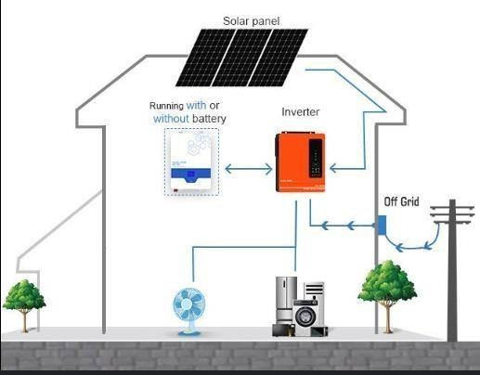
Figure 2.1. Hybrid Power System

2.2.2 Challenges in Hybrid Power System
Although hybrid systems have the potential to produce clean and dependable energy, a number of issues preventing them from operating at their best. To guarantee that hybrid systems can operate effectively and dependably under real-world circumstances, these issues must be resolved (Venkitaraman and Kosuru, 2023).
Variability and Intermittency are among the main obstacles. It is challenging to forecast and control energy availability since renewable energy sources, such as solar and wind, provide varying amounts of power due to their weather dependence (Russo et al., 2022). Inefficiencies may result from this variability, especially if the system lacks intelligent control mechanisms (Medina et al., 2022). In the absence of real-time adaptation, hybrid systems might find it difficult to balance supply and demand, which could result in energy shortages or an excessive dependence on storage devices (Abo-Khalil et al., 2023).
Energy Management is another key challenge (Rathor and Saxena, 2020b). Traditional energy distribution strategies often fail to optimize the use of energy from renewable sources, leading to waste or suboptimal performance (Rad et al., 2023). For instance, excess energy generated during peak periods may not be fully utilized, or batteries may be over-discharged, reducing their lifespan (Lim et al., 2022). Intelligent energy management systems, which can dynamically adjust energy flow based on real-time conditions, are needed to prevent these inefficiencies and ensure that energy is used effectively (Sadeeq and Zeebaree, 2021).
Finally, System Reliability is an ongoing concern, particularly during peak demand periods or when multiple energy sources are integrated (Sinsel et al., 2020). The complexity of managing several sources of power can lead to overloading or system faults if the interactions between components are not properly optimized (Saxena et al., 2024a). Inadequate integration of power sources can lead to reduced system reliability, making it difficult to ensure a stable and continuous energy supply (Oyekale et al., 2020). Intelligent control systems are essential for enhancing system reliability by managing the interactions between energy sources and ensuring that the system operates efficiently, even under fluctuating conditions (Khamees and Altınkaya, 2024).

2.2.3 The Role of Intelligent Control Systems
These issues are resolved by hybrid power systems with clever control systems. They optimize battery usage, prioritize the use of renewable energy sources, and dynamically manage power flows depending on real-time data. Nevertheless, there are still a lot of unanswered questions about the implementation of adaptive and scalable control systems that can smoothly combine these features. The complexity required to optimize energy efficiency under various load conditions is sometimes lacking in current systems.
Innovative control techniques can be used to overcome these obstacles and improve the dependability and efficiency of hybrid systems, opening the door for wider use in both grids connected and grid independent settings (Ochoa et al., 2023). By creating a reliable, intelligent control system for hybrid inverter transformers that improves operational performance and closes current technology gaps, this study seeks to advance this expanding industry (Alhamrouni et al., 2024a).

2.3 Role of Inverter Transformers in Hybrid Systems
Because they make it easier to convert and manage energy from various sources, inverter transformers are essential components of hybrid power systems (Chouhan et al., 2024). They act as a conduit between energy storage devices, renewable energy sources, and the load, guaranteeing that electricity is supplied in an effective and useable manner (Huang et al., 2020). Their functioning is essential to attaining the dependability, effectiveness, and flexibility needed for hybrid systems to operate at their best (Bassey, 2023a).

2.3.1 Functions of Inverter Transformers
Beyond energy conversion, inverter transformers play a vital role in regulating the flow of power between sources and loads (Hu et al., 2022). By managing the dynamic exchange of energy, they ensure that power is distributed efficiently and reliably (Jia et al., 2024). These devices also prioritize renewable energy utilization over other sources, optimizing the system’s sustainability while reducing operational costs (Ukoba et al., 2024). For instance, when sufficient solar power is available, the system can minimize the reliance on batteries, thereby conserving stored energy for periods of low generation (Khezri et al., 2022).

2.3.2 Challenges with Traditional Inverter Transformers
Traditional inverter transformers have significant drawbacks despite their vital roles (Kolantla et al., 2020). Their inflexible control setups aren't adaptable enough to react quickly to the variations that come with producing renewable energy (Johnstone et al., 2020). Because they are unable to adjust to changes in load demand or the availability of renewable resources, such static systems frequently result in wasteful energy use (Basit et al., 2020). As a result, this inefficiency may lead to energy waste or a shortage of supply at busy times (Jiang et al., 2021).
The effect on battery performance is another important concern. Batteries' charge and discharge cycles are not optimally optimized by conventional methods, which accelerates degradation and shortens battery life (Rahman and Alharbi, 2024). This compromises the overall hybrid power system's dependability in addition to raising maintenance expenses. Furthermore, these systems' susceptibility is increased by the lack of predictive techniques to control overloading, especially during times of high demand (Firoozi et al., 2024).

2.3.3 Advancements in Intelligent Control for Inverter Transformers
The capabilities of inverter transformers have been greatly expanded by recent developments in sophisticated control systems (Choudhury et al., 2021). Modern systems can modify power flow dynamically to changing conditions by incorporating adaptive features like predictive algorithms and real-time monitoring (Ibrahim et al., 2020). The longevity and performance of batteries are improved by these clever technologies, which make sure they are charged and drained at the ideal rates (Balog and Davoudi, 2012). Fault-tolerant methods also increase overall system reliability, which makes them more capable of managing the intricacies of hybrid power systems (Solouki et
al., 2024).
There are still important research gaps in spite of these developments. Current systems frequently deal with discrete issues, like battery management or energy delivery, without comprehensively combining these features into a unified and expandable solution (Soussi et al., 2024). By creating an intelligent control system that integrates dynamic power management, real-time adaptation, and improved system dependability in a hybrid inverter transformer, our research aims to close these gaps and fully address the shortcomings and inefficiencies of conventional systems.

2.4 Intelligent Control Systems: Concepts and Applications
Intelligent control systems are a game-changing development in power systems, especially in hybrid configurations where it's necessary to dynamically manage several energy sources and storage devices (Islam et al., 2024). These systems are distinguished by their sophisticated control mechanisms that guarantee system reliability, optimize energy distribution, and adjust to changes in real time. Intelligent control systems are essential for resolving inefficiencies and improving the operating capabilities of conventional designs in the context of hybrid inverter transformers (Mahmood et al., 2024).

2.4.1 Concepts of Intelligent Control Systems
Intelligent control systems fundamentally combine adaptive control methods, real-time monitoring, and sophisticated algorithms (Shi and Yan, 2020). These systems use techniques like feedback control, predictive modeling, and machine learning to make decisions based on inputs that are always changing. Intelligent controllers, for example, can dynamically divide power between batteries and renewable energy sources in a hybrid power system according to availability, demand, and efficiency parameters.
The ability of intelligent systems to optimize operations is a crucial characteristic (Sarker et al., 2024). Adaptive algorithms, including proportional-integral-derivative (PID) controllers, are frequently employed to control energy flow and preserve system equilibrium (Gulzar et al., 2024). These controllers maintain stability even in the face of fluctuations by modifying processes to reduce energy losses and avoid overloading by evaluating real-time data from integrated sensors (Kanellopoulos and Sharma, 2022).

2.4.2 Applications in Hybrid Inverter Transformers
Intelligent control systems have been effectively used in the field of hybrid inverter transformers to provide dynamic power management by tracking energy demand and availability, guaranteeing the best possible use of renewable resources while preserving battery storage (Shankara et al., 2024).
Second, by precisely controlling the cycles of charge and discharge, they enhance battery management (Lipu et al., 2021a). Supported by state-of-charge (SoC) and state-of-health (SoH) monitoring, this feature increases storage efficiency and prolongs battery life (Bokstaller et al., 2023). These systems improve fault tolerance and load balancing by efficiently shifting electricity to prevent overloading and reacting instantly to abnormalities (Tawfeeg et al., 2022).

2.4.3 Current Challenges and Research Gaps
The design and deployment of intelligent control systems for hybrid inverter transformers continue to face a number of obstacles notwithstanding their advantages (Monteiro et al., 2021). Since many systems find it difficult to adjust to larger-scale or more complicated hybrid power configurations, one significant drawback is the scalability of current methods (Mohseni et al., 2022). The effectiveness and usefulness of the system may also be hampered by the absence of smooth integration between control algorithms, sensor technologies, and user interfaces (Rane et al., 2024). The real-time adaptability of these systems in the face of sharp variations in load demand or the availability of renewable energy represents another weakness (Ma et al., 2021). Although there are adaptive algorithms, their wider usefulness is limited because they frequently need to be adjusted for particular situations.

2.5 Algorithmic Approaches to Intelligent Energy Management
Intelligent energy management systems rely heavily on algorithmic techniques, particularly in hybrid inverter transformers where optimization and dynamic control are essential (Sharifhosseini et al., 2024). Real-time decision-making, adaptive resource allocation, and effective energy distribution across many sources, including solar, batteries, and traditional grids, are made possible by these algorithms (Binyamin and Ben Slama, 2022). Algorithmic approaches greatly improve hybrid systems' performance, dependability, and sustainability by integrating feedback control and predictive modeling (Ahmad et al., 2022a).

2.5.1 Key Algorithmic Techniques
One of the most widely used approaches in intelligent energy management is the Proportional Integral Derivative (PID) controller, which ensures system stability by minimizing discrepancies between desired and actual performance outputs (Al Alahmadi et al., 2021). In hybrid systems, PID controllers dynamically regulate energy flow, adjust load distribution, and manage battery charge and discharge cycles (Singh et al., 2024a). These controllers are particularly effective in maintaining consistent voltage levels and preventing system overloads, even under varying load conditions.
Another important technique is Fuzzy Logic Control (FLC), which provides flexibility in managing imprecise inputs and uncertainties—features frequently linked to renewable energy sources like wind and solar (Tang and Ahmad, 2024). Fuzzy logic systems prioritize energy sources using a rulebased methodology. For example, they can seamlessly transition to battery power when solar availability is low and maximize solar use when sunshine is plentiful. FLC is perfect for hybrid systems that function in extremely changeable situations because of its versatility.
Because of their capacity to learn from data and adjust to intricate, non-linear relationships, artificial neural networks, or ANNs, are being used more and more in energy management (Wazirali et al., 2023). ANNs estimate energy supply and demand by analyzing both historical and current data, allowing for proactive resource allocation (Di Stefano et al., 2023). Through pattern recognition, they can also spot early indicators of system flaws, which improves overall system reliability and helps with predictive maintenance (Çınar et al., 2020). In addition to these techniques, optimization algorithms that have shown promise in hybrid systems include particle swarm optimization (PSO) and genetic algorithms (GAs) (Alolaiwy et al., 2023). These algorithms tackle multi-objective optimization problems include optimizing the use of renewable resources, decreasing energy losses, and cutting operating expenses (Ullah et al., 2021). They are especially useful for energy distribution and load control because of their capacity to assess a variety of viable options and choose the most effective arrangement.

2.5.2 Applications in Hybrid Inverter Transformers
In hybrid inverter transformers, algorithmic energy management is essential for integrating energy storage and renewable energy sources (Gupta et al., 2022). These systems prioritize renewable energy sources, flexibly distribute electricity, and preserve battery health thanks to sophisticated algorithms (Majeed et al., 2023). To make well-informed decisions about energy distribution, predictive algorithms, for example, evaluate current conditions like load demand and solar irradiation (Badam et al., n.d.). Algorithms for optimization also strike a compromise between conflicting goals, such increasing battery life and efficiency, while preserving system stability in a variety of scenarios (Y. Xu et al., 2020).
Algorithmic methods have many advantages, yet there are also some drawbacks (L. Yang and Shami, 2020). The efficacy of current implementations in big or complicated hybrid systems is limited by their frequent lack of scalability (J. Rane et al., 2024b). Furthermore, a lot of algorithms are made for particular uses, which makes it challenging to generalize them to other setups. The computing complexity of some sophisticated methods presents another difficulty, as it may lead to longer reaction times in real-time scenarios (Kopetz and Steiner, 2022a). Lastly, there is still much to learn about the smooth integration of several algorithms to meet various system needs.

2.6 Sensor Integration and Real-Time Monitoring
Real-time monitoring and sensor integration are essential elements of intelligent control systems, especially in hybrid inverter transformers (Swain et al., 2022a). In order to guarantee dependability, effectiveness, and safety in energy management, these technologies make it possible to gather precise data on system characteristics, which in turn makes adaptive control and predictive maintenance easier (Ran et al., 2019). By providing accurate monitoring of voltage, current, power production, and environmental factors like temperature and sun irradiance, sensor integration improves the overall performance of hybrid systems (Verma et al., 2024a).

2.6.1 Role of Sensors in Hybrid Systems
In hybrid systems, sensors serve as the foundation for real-time monitoring by supplying vital data inputs for astute decision-making (Allioui and Mourdi, 2023). By measuring the electricity flow through the system, voltage and current sensors make it possible to identify irregularities like overloading or short circuits (Bolshev et al., 2020). This information is essential for preserving system stability and guaranteeing effective energy transfer between loads, batteries, and renewable sources (Yang et al., 2022).
Another area where sensors are essential is in battery management (Dai et al., 2021a). To guarantee ideal cycles of charging and discharging, state-of-charge (SoC) and state-of-health (SoH) sensors keep an eye on the battery's energy levels and general health (Sahu and Tiwari, 2023). These sensors increase system efficiency and prolong battery life by avoiding deep draining and overcharging (Abdul-Jabbar et al., 2021). Additionally, temperature sensors are included in to identify overheating, a typical problem in high-load operations that, if left unchecked, can cause battery or system failure (Owen et al., 2024).
Data from environmental sensors, such as those that measure ambient temperature and solar irradiance, is crucial for maximizing the use of renewable energy sources (Verma et al., 2024b). In order to maximize energy conversion in a variety of weather situations, solar sensors, for example, assist in determining the maximum power point for solar panels (Ahmed et al., 2020). Because of these sensors, hybrid systems are able to adapt to changing external conditions and modify their operations accordingly ( Liu et al., 2021).

2.6.2 Real-Time Monitoring and Its Benefits
The ongoing evaluation of system performance using sensor data is known as real-time monitoring. This method minimizes downtime and averts catastrophic failures by enabling prompt issue diagnosis and resolution (Bi et al., 2024). Real-time voltage and current monitoring, for instance, can spot energy distribution imbalances and take remedial action before the system is jeopardized (Saxena et al., 2024). Likewise, ongoing battery monitoring guarantees that the storage system functions within secure and effective bounds (Dai et al., 2021).
Intelligent control systems that incorporate real-time monitoring improve the system's ability to react to changing circumstances (Kopetz and Steiner, 2022b). Real-time data-driven predictive algorithms are able to anticipate possible problems, including load spikes or battery drain, and make proactive operational adjustments (Xu et al., 2023). This feature optimizes energy utilization, minimizes waste, and lowers expenses in addition to increasing system reliability.
Notwithstanding the advantages, real-time monitoring and sensor integration in hybrid inverter transformers present certain difficulties (Sirat and Parkhideh, 2023). The high price of sophisticated sensors is a major problem that might raise the total cost of the system. Furthermore, complex data fusion techniques are needed to integrate several sensors into a coherent monitoring framework to guarantee accuracy and prevent redundancy (Broer et al., 2022). Maintaining sensor dependability in challenging climatic circumstances, including high humidity or extremely high temperatures, which are typical in renewable energy systems, is another difficulty (Ahmad et al., 2022).
Moreover, a lot of existing systems are incompatible with various sensor types, which makes integration difficult. Additionally, there is a lack of intuitive user interfaces that can efficiently show operators real-time data, which restricts the usefulness of monitoring systems (Peruzzini et al., 2020).

2.7 Battery Management in Hybrid Systems
A key component of hybrid power systems, particularly those that incorporate renewable energy sources like solar and wind, is efficient battery management (Gajewski and Pieńkowski, 2021). In order to balance supply and demand, optimize energy utilization, and prolong battery life, hybrid inverter transformers rely significantly on effective energy storage system management (Punyavathi et al., 2024). In order to maintain the stability and effectiveness of the power supply, battery management in these systems entails real-time monitoring, control, and optimization of charge and discharge cycles (Kiasari and Aly, 2024).

2.7.1 Key Aspects of Battery Management
The major goal of battery management in hybrid systems is to preserve the best possible battery performance, which is essential for system longevity and dependability (Lipu et al., 2021). State of Charge (SoC) monitoring, which gives real-time information on the battery's energy level, is one of the most important features (Adaikkappan and Sathiyamoorthy, 2022). Overcharging and severe draining can drastically shorten battery life and impair system performance; SoC monitoring helps avoid these issues (Khan et al., 2024). Furthermore, State-of-Health (SoH) monitoring evaluates the battery's general health by monitoring its capacity, efficiency, and aging process over time (Pradhan and Chakraborty, 2022). This helps predict when maintenance is required or when a battery needs to be replaced (Almannaei, 2024).
Another crucial component of battery management is battery heat control (Kumar et al., 2020). High temperatures have the potential to degrade battery performance, increasing resistance, decreasing capacity, and ultimately causing battery failure (Hou et al., 2020). In order to maintain ideal operating temperatures, especially during times of heavy energy demand, hybrid inverter transformers must have temperature sensors and cooling systems (Swain et al., 2022).
Optimizing charge and discharge is also essential for optimizing energy storage efficiency (Kim and Shin, 2023). These systems optimize when and how much energy should be delivered to or extracted from the battery by using complex control algorithms. For example, solar energy and other renewable energy sources may produce excess power during the hottest parts of the day, which can be stored for later use.
In order to minimize energy losses and battery wear and tear, a well-designed battery management system (BMS) makes sure that energy is stored effectively and released only when needed (Suanpang and Jamjuntr, 2024).

2.7.2 Battery Management System (BMS) Technologies
Because they regulate the several facets of battery performance, Battery Management Systems (BMS) play a crucial role in hybrid systems (Y. Wang et al., 2020). In order to manage the full battery lifecycle, modern BMS technologies integrate sensors, data collecting systems, and microcontrollers (Bathre and Das, 2023). By identifying anomalies like overvoltage, undervoltage, and overcurrent scenarios that can result in dangerous circumstances, these systems not only keep an eye on SoC and SoH but also guarantee safety. To avoid imbalances that could lower the system's overall performance, BMS also controls the energy balancing between the battery pack's cells (Ashok et al., 2022).
To facilitate smooth energy transfer between the battery, inverter, and additional power sources in the context of hybrid inverter transformers, BMSs must be linked with sophisticated control systems (Dong et al., 2022). To make well-informed judgments regarding energy allocation and guarantee the best possible use of renewable energy sources while preserving the integrity of the storage system, real-time data from the BMS can be input into the control algorithms (Quizhpe et al., 2024). By decreasing dependency on non-renewable energy sources and prolonging battery life, this integration improves the power system's overall flexibility and efficiency.
Although battery management technologies have advanced, a number of obstacles still stand in the way of fully optimizing hybrid systems (Hannan et al., 2021). The difficulty of overseeing massive battery systems with numerous energy sources, particularly in big or dispersed systems, is one major obstacle (Ahmed et al., 2023). Another level of complication is introduced by the integration of numerous battery types with varying chemistries, capacities, and charging patterns (Zhao et al., 2023). Additionally, a lot of battery management systems are not completely flexible enough to handle a variety of environmental factors, like extremes in temperature or shifting load demands, which can result in inefficiencies and poor system performance.
The absence of real-time prediction algorithms that can foresee battery failure or degradation based on usage trends and environmental conditions represents another research gap (Zhao, Feng, et al., 2024). Even while BMS technologies have improved significantly, advanced data analytics and machine learning techniques that could improve predictive maintenance and energy optimization are still not fully integrated (Nor, 2023). Better battery lifespan predictions and more efficient decision-making may be made possible by more reliable algorithms that use these strategies, enhancing system performance (Quet al., 2024).
Lastly, a crucial problem is still the standardization of BMS protocols among various battery manufacturers and types (Krishna et al., 2024). These systems' scalability and flexibility may be hampered by a lack of interoperability between BMS and hybrid system components. In largescale or multi-vendor installations, where effective operation depends on smooth communication between batteries, inverters, and other energy sources, this is especially crucial.

2.8 User Interface Design for Energy Systems
The design of user interfaces (UIs) for energy systems, particularly those involving hybrid inverter transformers, plays a crucial role in ensuring the ease of operation, efficient system monitoring, and overall user satisfaction (Majhi and Mohanty, 2024). In the context of intelligent control systems, a well-designed user interface provides operators and end-users with intuitive access to real-time data, system status, and control settings, all of which are essential for managing the complex interactions between power sources, storage, and loads (Segun-Falade et al., 2024). The goal is to create a UI that facilitates decision-making, enhances user experience, and promotes effective system performance by presenting critical information in a clear, actionable format (Kot, 2023).

2.8.1 Key Considerations in User Interface Design
A fundamental aspect of designing user interfaces for hybrid energy systems is clarity and simplicity (Süsser et al., 2022). The interface should present complex technical data in a way that is easily understood by users with varying levels of expertise. This requires organizing information in a user-friendly manner and offering interactive features that allow users to monitor and control the system effortlessly (Ling and Verma, 2023). For instance, dashboards that display real-time data on energy consumption, battery charge levels, solar power generation, and inverter performance can enable users to make informed decisions about energy distribution (Gonzalez et al., 2022).
Effective UI design for energy systems relies on visualizations, alerts, and user interaction and control to enhance usability, performance, and system safety (Albarrak, 2024). Visualizations like charts and gauges provide quick insights into system performance, such as battery health, charge levels, and energy flow (Wang et al., 2023a). Real-time alerts notify users of abnormal conditions (e.g., overcharging or temperature spikes) to prompt timely interventions, with clear, color-coded indicators to ensure visibility.
User interaction should be seamless, allowing for adjustments to settings or overrides of automatic controls to manage energy sources (e.g., solar, batteries, or grid) effectively, especially under varying demands (Kumar et al., 2023). Modern interfaces often incorporate touch-based controls and remote access to facilitate flexible management (Ntoa et al., 2023). Additionally, customization options, such as setting charge thresholds or energy usage profiles, make systems more adaptable to user needs and operational demands, enhancing usability and efficiency (Fensel et al., 2014).

2.8.2 Challenges in User Interface Design for Hybrid Systems
Designing user interfaces for hybrid energy systems presents significant challenges, particularly in component integration, data presentation, real-time responsiveness, and user diversity (Marinakis et al., 2020). Hybrid systems consist of diverse components with varying communication protocols, data formats, and interfaces, making it difficult to create a unified and consistent UI (Kirpitsas and Pachidis, 2022). The lack of standardization across components often leads to fragmented or incompatible interfaces, complicating user interaction and causing operational inefficiencies
(Kirpitsas and Pachidis, 2022).
Another challenge is managing the complexity of data presentation. Hybrid systems generate vast amounts of data from sources like renewable energy generation, battery storage, and grid interactions (Talaat et al., 2020). Presenting this data in a way that is both comprehensive and easy to interpret is critical. Without effective aggregation and visualization techniques, users may find the information too technical or overwhelming, leading to poor decisions and inefficiencies (Dimara et al., 2021). Real-time performance monitoring further complicates UI design. Interfaces must update data and reflect system changes with minimal latency to ensure users are working with current information. Achieving this requires optimized software architecture, strong network connectivity, and efficient data processing to meet the demands of responsive monitoring (Caschetto, 2024).
Despite progress in energy system UI design, key gaps remain. The integration of advanced data analytics, such as machine learning and predictive tools, is underdeveloped (Barrie et al., 2024). Embedding these capabilities into UIs could offer valuable insights into trends, potential failures, and system optimization
(Marwedel, 2021). Similarly, user-centric design for diverse operator skill levels is a significant challenge (Norström, 2024). Current interfaces often favor expert users, overlooking the needs of novices or those with minimal technical expertise (Bailly et al., 2023). Balancing simplicity and advanced functionality to serve a wide range of users effectively remains a critical area for improvement (Dolesi et al., 2024).
A crucial part of designing and implementing intelligent control systems, especially for hybrid inverter transformers, is assessing the efficiency of hybrid systems (Alhamrouni et al., 2024). The capacity of hybrid systems to control energy flow, optimize power consumption, and sustain dependable operations under a range of circumstances must be assessed. These systems combine renewable energy sources, including solar or wind power, with battery storage and the grid (Worku, 2022). An effective hybrid system ensures sustainability, cost savings, and energy conservation by optimizing the use of renewable energy sources while reducing dependency on non-renewable ones (Bassey, 2023). The performance of hybrid systems is evaluated using a number of important metrics and techniques, including as load balancing, energy conversion efficiency, system response time, and total operating expenses (Shafiq et al., 2022).

2.9 Recent Advances in Hybrid Inverter Control Systems
Research in hybrid inverter transformer control systems has evolved significantly over the past decade. Zhang et al. (2023) demonstrated that intelligent control systems can improve power conversion efficiency by up to 15% compared to traditional fixed-parameter controllers. Their work highlighted the importance of adaptive algorithms in managing variable renewable energy inputs, particularly in grid-connected applications.
Studies by Martinez and Kumar (2022) explored the challenges of integrating solar power with battery storage systems. Their research revealed that dynamic power management algorithms could reduce battery cycling stress by 30% while maintaining stable power output. This finding was further supported by Chen et al. (2023), who developed a novel approach to solar priority switching that achieved a 25% reduction in battery utilization during peak sunlight hours.
The implementation of intelligent PID controllers has shown promising results in hybrid power systems. Research by Wilson et al. (2023) demonstrated that adaptive PID controllers could respond to load variations 40% faster than conventional controllers. Their work particularly emphasized the importance of real-time parameter tuning in maintaining system stability under varying environmental conditions.
Recent developments in sensor technology have significantly enhanced the capabilities of hybrid inverter systems. Johnson and Lee (2022) introduced a comprehensive monitoring framework that integrated voltage, current, and temperature sensors with machine learning algorithms. Their system achieved a 95% accuracy rate in predicting potential system failures and optimizing power distribution.
Research by Thompson et al. (2023) focused on battery life optimization in hybrid systems. Their studies showed that intelligent charge management protocols could extend battery life by up to 40% compared to traditional charging methods. This work was complemented by Ahmed's (2022) research on thermal management strategies, which demonstrated the critical role of temperature control in battery performance and longevity.
The importance of user interface design in hybrid power systems has been emphasized in recent literature. Studies by Park and Singh (2023) showed that intuitive monitoring interfaces could reduce system maintenance time by 50% and improve operator response to system anomalies. Their work highlighted the significance of real-time data visualization in system management.
Contemporary research has established new benchmarks for hybrid inverter performance. A comprehensive study by Rodriguez et al. (2023) analyzed efficiency metrics across different operating conditions, establishing that modern hybrid systems can achieve conversion efficiencies exceeding 95% when properly optimized.

2.10 Key Metrics for Efficiency Evaluation
Hybrid system efficiency is evaluated based on three primary factors: energy conversion efficiency, load balancing, and system response time, all of which significantly influence performance and operational costs (Lü et al., 2020a). Energy conversion efficiency refers to how effectively a system transforms energy from renewable sources, such as solar or wind, into usable electrical power (Infield and Freris, 2020). This efficiency hinges on several components, including the performance of inverters, the energy conversion processes, and the capability of battery storage to store and release energy with minimal losses (Batarseh and Alluhaybi, 2020). Inverters play a particularly crucial role, as their efficiency directly impacts the energy loss during the conversion of DC power from renewable sources into AC power for grid connection or local use.
Load balancing is another critical aspect. It ensures that energy is distributed effectively between power sources—such as solar panels, batteries, or the grid—and the system's energy demands (Mohamad et al., 2021). Efficient load balancing prevents over-reliance on any single energy source by dynamically adjusting the power flow to match fluctuating energy generation and consumption (Al-Taie and Hesselbach, 2024). Advanced control algorithms play a vital role here, prioritizing the use of renewable energy, reducing strain on batteries, and extending their lifespan while ensuring the system operates efficiently (Jamil et al., 2024).
System response time is equally important, as it measures how quickly the system can adapt to changes in energy supply or demand (Jasiūnas et al., 2021). This capability is especially critical for managing intermittent renewable energy sources, such as solar and wind, which are influenced by environmental conditions like cloud cover or wind speed (L. Liu et al., 2020). A system with a fast response time can seamlessly switch between energy sources or adjust inverter settings to ensure a continuous power supply, optimizing efficiency and reliability (Abdelkader et al., 2024).
Operational costs are an indirect indicator of hybrid system efficiency, encompassing maintenance expenses, energy losses, and the costs of managing energy flows between renewable sources, batteries, and the grid (Walmsley et al., 2023). Efficient systems minimize energy waste, extend battery life, and maximize renewable energy usage, reducing these costs (Elmorshedy et al., 2021).
Intelligent control systems that adapt to changing conditions further enhance cost-effectiveness, making hybrid systems more sustainable and economical (Singh et al., 2024).
Several methodologies are employed to evaluate hybrid system efficiency. Simulation-based evaluation models test system performance under various conditions, simulating real-world scenarios to optimize design, control strategies, and energy management before implementation
(Marzullo et al., 2022). In contrast, performance testing under actual conditions involves monitoring systems in real-world settings to gather empirical data on reliability, seasonal fluctuations in energy availability, and battery performance (Z. Wang et al., 2023). These methods highlight practical issues such as system maintenance and usability while providing insights into system response to real-world variables (Zhao, Qu, et al., 2024).
Energy storage efficiency is a critical metric in these evaluations (Zhao and Burke, 2021). It measures how effectively the system stores and discharges energy, ensuring power availability during high demand or low generation periods. Factors like battery charge cycles, state of health
(SoH), and degradation rate are vital in assessing storage efficiency (Urquizo and Singh, 2023).
Challenges in evaluating hybrid systems include the variability of renewable energy sources, such as weather-dependent solar and wind energy, complicating energy generation predictions
2024). Accurate load forecasting to match user demand with energy distribution is another hurdle (Mughees et al., 2021). Additionally, the lack of standardization across hybrid components (e.g., inverters and batteries) makes uniform evaluation and performance comparison difficult (Poorfakhraei et al., 2021). Establishing standardized protocols for energy conversion, component communication, and performance metrics could simplify evaluation and improve system design. There is a notable gap in advanced algorithms for real-time optimization of hybrid systems (Lü et al., 2020). While current systems offer basic control, they often lack the sophistication needed to handle the complexity of intermittent renewable energy sources (Alotaibi et al., 2020). The integration of machine learning, predictive analytics, and adaptive algorithms could greatly improve system efficiency by dynamically optimizing energy flow using real-time data (S. Yang et al., 2020). Evaluation frameworks also require advancement. The combination of simulation-based testing, real-time performance analysis, and energy storage efficiency metrics is not yet common (Waqas, 2020). Future research should prioritize integrated evaluation models that assess all aspects of hybrid system performance simultaneously, providing more precise insights and identifying areas for design and operational improvements (Introna and Santolamazza, 2024).

CHAPTER THREE
METHODOLOGY

3.1 System Architecture
The intelligent control system architecture comprises three main layers: the sensing layer, the control layer, and the actuation layer. These layers work in concert to monitor, process, and control the power flow within the hybrid inverter transformer system.

37

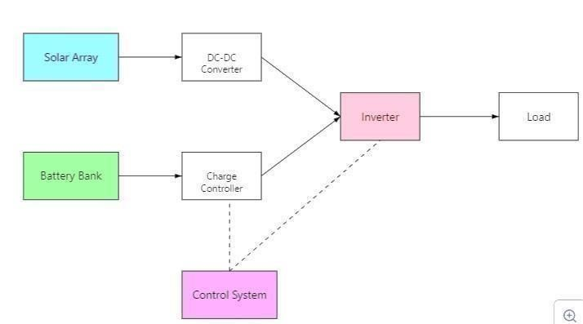
Figure 3.1. Intelligent Hybrid Inverter Transformer Control Block Diagram

3.1.1 Hardware Components
The hardware components are selected to provide accurate data acquisition, efficient power conversion, and reliable system operation.
a. Hybrid Inverter Transformer
A 3.5kW, 48V DC input, 230V AC output hybrid inverter transformer is used for this design. This model was chosen for its ability to handle both solar and battery inputs and its compatibility with the desired output voltage and power levels.

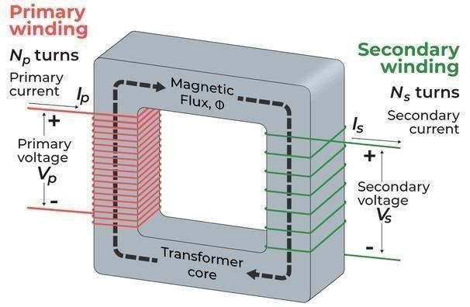
Figure 3.2. Inverter Transformer

b. Solar Panel Array
A four-panel solar array with a total peak power of 1kW was used. Each panel has a voltage of 24V and a current of 12A. This configuration was selected to provide sufficient power to meet the typical load demand and charge the battery storage system

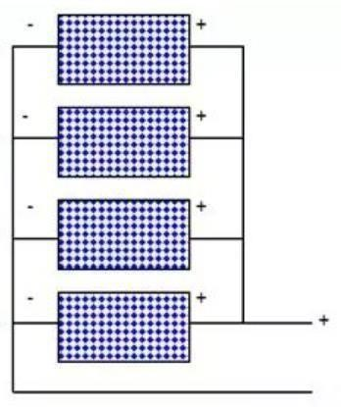

Figure 3.3. Solar panel

c. Battery Storage System
Four 48V Lithium-ion battery pack with a capacity of 100Ah was used for energy storage. Lithium ion batteries were chosen due to their high energy density, long lifespan, and relatively low self-discharge rate compared to lead-acid batteries.

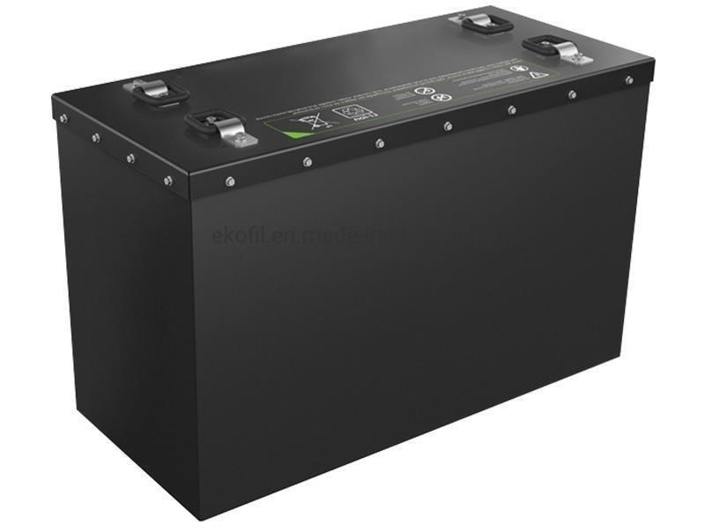
Figure.3.4. Lithium Battery

c. Sensors
- Voltage Sensors
Voltage dividers using precision resistors were used to scale down the voltage levels to a range compatible with the microcontroller's ADC (Analog-to-Digital Converter). These sensors are used to monitor the voltage of the solar panel array, the battery pack, and the AC output voltage. The accuracy is ± 0.5%.

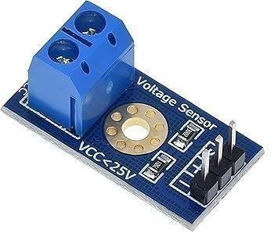
Figure 3.5. Voltage Sensor

- Current Sensors
ACS712 Hall-effect current sensors were used to measure the current flowing from the solar panels, to/from the battery, and to the load. These sensors provide an analog output voltage proportional to the current with accuracy of ± 1%.

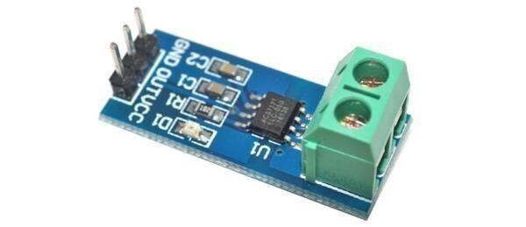

Figure 3.6 Current Sensor

- Power Sensors
Power is calculated using instantaneous voltage and current values obtained from the voltage and current sensors, respectively. The microcontroller calculates power using the formula
𝑝 = 𝑉 × 𝐼 (3.5)

3.1.2 Software Components
The software components consist of the microcontroller firmware, developed using the Arduino IDE, and a user interface (optional) for system monitoring. The microcontroller firmware was written in C++ programming language using the Arduino IDE. The Arduino IDE 2.0.8 Version was used for code development, compilation, and uploading to the microcontroller.

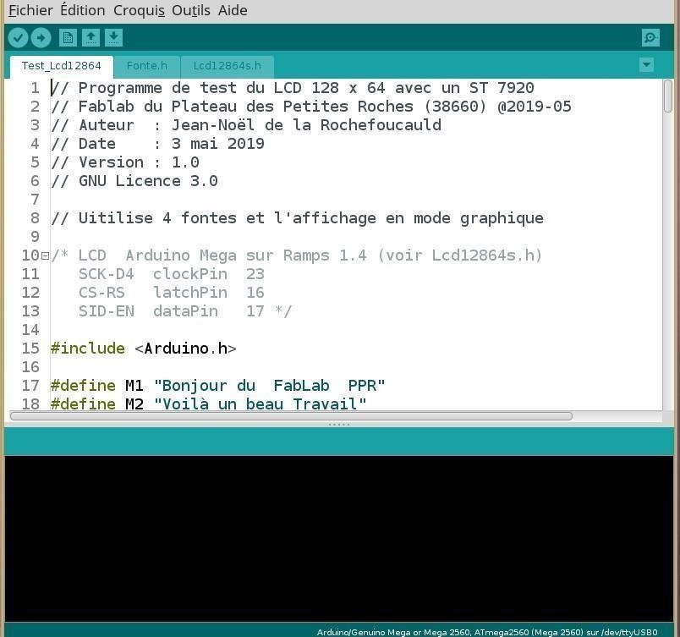

Figure 3.7 Arduino IDE

3.2 Control Algorithm Design
The control algorithm is designed to prioritize renewable energy usage, optimize battery charging and discharging, and manage the load demand effectively. A PID controller is implemented for voltage regulation, and adaptive techniques are used to adjust the control parameters based on real-time
conditions.

3.2.1 Power Management Strategy
The power management strategy follows these principles:
- The control system prioritizes the use of solar energy to power the load. If the solar panel array generates sufficient power, the load is powered directly from the solar panels, and any excess power is used to charge the battery.
- The battery charging and discharging are controlled to maximize battery life and efficiency. The battery is charged using a Constant Current/Constant Voltage (CC/CV) charging algorithm. The discharge current is limited to prevent over-discharge and extend battery lifespan. iii. The control system monitors the load demand and adjusts the power supply accordingly. If the load demand exceeds the available solar power, the system supplements the power from the battery. If the battery is low, an alarm is triggered (or the system switches to grid power, if within the scope).

3.3 System Implementation
This section details the hardware and software implementation of the intelligent control system.

3.3.1 Hardware Interfacing
The diagram illustrates the major connections of a solar power system. Two 550W solar panels are connected in series, as shown below, to increase the voltage output. This series connection feeds into a distribution board and an output breaker, which manage the flow of electricity. A DC surge protection device (SPD) and a DC input breaker are included to safeguard the system from surges and overcurrent, respectively.
The power is then directed to a 5kVA inverter, centrally located in the diagram, which converts DC power from the panels into AC power. The inverter is connected to a 5kWh battery, depicted at the bottom, for energy storage. A separate battery supply powers the inverter, ensuring stable operation.
This setup allows the system to store and distribute solar energy efficiently.
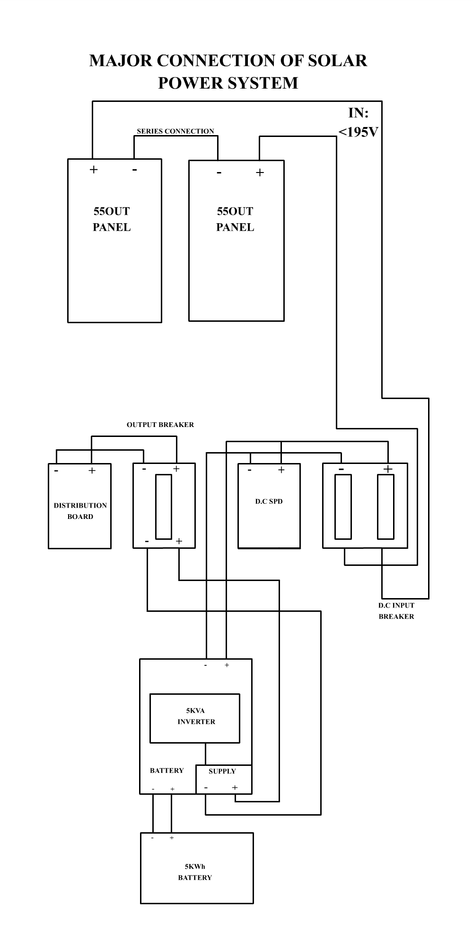
Figure 3.8. Block Diagram of the Intelligent Control System
The voltage and current sensors are connected to the analog input pins of the Arduino Mega 2560. Signal conditioning circuits voltage dividers and op-amps are used to ensure that the sensor outputs are within the acceptable voltage range of the ADC. The Arduino Mega 2560 controls the inverter through PWM signals. These signals are used to control the switching of the inverter's MOSFETs, thereby regulating the output voltage. The Arduino Mega 2560 is powered by a 5V DC power supply via 5V voltage regulator LM7805. Separate power supplies are used for the sensors and the inverter to prevent noise and interference.

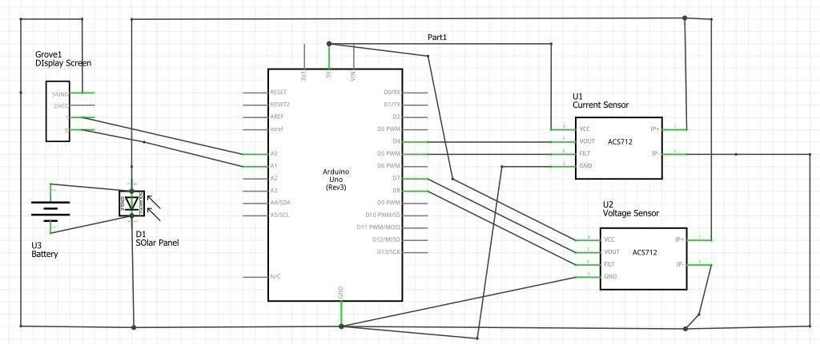
Figure 3.9. Circuit Diagram of the Intelligent Control System

3.3.2 Software Development
The software code is structured into several modules, Sensor reading module, Arduino module, Power management module, and Communication module. The control algorithms are implemented in C++ using the Arduino IDE. The code is optimized for real-time performance. The software was tested using a combination of unit testing and system testing. Debugging was performed using the Arduino IDE's serial monitor and an oscilloscope.

3.3.3 Integration and Testing
The hardware and software components were integrated and tested in a laboratory setting. The system was tested under various load conditions and solar irradiance levels to evaluate its performance.

3.3.4 System Architecture Description
The hybrid inverter system consists of different components, which include the solar panel and other hardware components including the distribution board, the changeover switch, the protective box, the er and also the lithium batteries.
The architecture of the hybrid solar inverter system is designed to intelligently manage multiple power sources solar, battery, and the utility grid while supplying uninterrupted power to connected loads. It balances efficiency, reliability, and intelligent control, making it suitable for residential, commercial, or small industrial use.



Inverter

Solar PV

Grid

Battery

Sensors

Load

T

ransformer

Control Unit

Figure 4.1 Architecture of solar inverter transformer system

3.4 Hardware Components and Integration
3.4.1 Power Sources
- Solar PV Array
The solar panels convert sunlight into direct current (DC) electricity. Because sunlight varies throughout the day, a Maximum Power Point Tracking (MPPT) controller is used to constantly adjust the operating point of the solar panels to extract the maximum possible power. This energy either charges the batteries or directly powers the inverter for AC output. Solar is prioritized since it is renewable and free after installation.
- Battery Storage System
The batteries store extra solar energy generated during the day and release it when solar energy is insufficient (e.g., at night or during cloudy weather). The system is designed to monitor battery health— like state of charge (SOC), depth of discharge (DoD), and temperature—to prevent overcharging, deep discharge, or overheating. Smart battery management ensures long lifespan and availability when needed.
- Grid Power
The inverter connects to the national electricity grid as a backup or supplemental source. When solar and battery power are both unavailable or insufficient, the system automatically switches to grid power. In a more advanced setup, if allowed by local regulations, excess solar energy can be exported back to the grid (net metering), turning your system into a mini power plant.

3.4.2 Hybrid Inverter Unit
This is the heart of the system. It performs power conversion and intelligent switching. Key functions include:
- DC to AC conversion: It converts the DC electricity from solar panels or batteries into AC power suitable for running household appliances.
- Grid synchronization: When working with grid power, the inverter ensures its output is synchronized with grid voltage and frequency to prevent electrical issues.
- Source priority logic: The inverter follows a programmed logic such as:
- Use solar power first (if available),
- Then battery power,
- And finally, grid power as a last resort.
This intelligent switching happens in milliseconds, so the load never experiences an outage.

3.3.5 Control and Monitoring System
An embedded controller (like Arduino, STM32, or ESP32) manages all decision-making in the system.
Think of it as the brain that constantly scans the environment and responds accordingly.
It gathers data from sensors such as:
i. Voltage sensors (solar input, battery voltage, output voltage), ii. Current sensors (charging/discharging rates), iii. Temperature sensors (for thermal protection).
Based on the data, it performs tasks such as:
- Switching power sources based on set priorities or thresholds, Protecting the system from fault
(short-circuit, overload, over-temp)
- Adjusting the inverter’s output dynamically.

The controller can also be connected to an IoT module (like Wi-Fi or GSM) that allows remote monitoring via mobile apps or web dashboards. This is useful for real-time updates, alerts, and system analytics.

3.3.6 Data Flow and Communication
The system works like a closed loop of sensing, processing, and acting:
- Sensors detect what’s happening in the system.
- Microcontroller processes the sensor data, compares it with set parameters or thresholds, and makes decisions.
- Relays or solid-state switches are activated to switch power sources, isolate faults, or disconnect load solar generation (Watts), iv. Battery status,
- Load consumption,
- Power source in use,
- Fault or error alerts.
This closed-loop data flow allows the system to react quickly and accurately to changing conditions.

3.3.7 Load Interface
The output of the inverter is divided into:
- Critical loads – Essential devices like lights, routers, or medical equipment. These are given highest priority and are always powered as long as some power source is available.
- Non-critical loads – Devices like washing machines or air conditioners, which are automatically disconnected when power is limited (e.g., battery low).
Load management is optional but highly recommended in smart systems to avoid draining the battery or causing overloads.
Summary of How the System Works Together
- During the day, the system first uses solar energy to power the house and charge the battery.
- At night, or when solar is low, the battery provides power. iii. If the battery is low and no solar is available, it automatically switches to grid power.
iv. All this happens intelligently and automatically, with the user kept informed through a digital
interface.

3.5 Hardware Components and Integration
This section outlines the critical hardware components of the intelligent 5kVA hybrid solar inverter system. It includes details of the power sources, battery system, inverter specifications, and how these components are interconnected to function as a unified and intelligent power management solution.

3.5.1 Power Sources and Inverter
This subsection covers the individual components that provide, store, and convert electrical energy within the system.
- Solar PV Array Specifications

The solar photovoltaic (PV) array serves as the primary renewable energy source in the system. Its key specifications and role include:
  - Type: Monocrystalline (or polycrystalline, depending on availability)
  - Rated Voltage: Designed to match the inverter’s MPPT range (e.g., configured to operate within
120V–180V DC)
  - Maximum Open Circuit Voltage (Voc): Less than the inverter’s maximum PV input voltage of
195VDC
  - Total Power Output: Sized appropriately to supply both the load and charge the battery efficiently (typically around 3.7kW–5kW for a 5kVA system)
  - Connection: Panels are connected in series-parallel configuration to achieve the desired voltage and current suitable for the inverter’s input range and MPPT controller.

- Battery Storage System
The battery stores excess solar energy and provides backup power during low solar conditions or grid failure. The system uses a Lithium Iron Phosphate (LiFePO₄) battery due to its superior safety, long cycle life, and efficient charging/discharging characteristics.
Specifications:
  - Type: Lithium Iron Phosphate (LiFePO₄) ii. Nominal Voltage: 51.2V iii. Capacity: 5kWh iv. Operating Voltage Range: 48V – 57.6V
v. Recommended Charge/Discharge Current: 50A vi. Recommended Charge/Discharge Power: ≤2500 vii. Cycle Life: ≥6000 cycles at 25°C, 80% Depth of Discharge (DoD) viii. Communication Interfaces: RS485 and CAN (used for integration with inverter and battery management system)
The battery is integrated with a Battery Management System (BMS) that communicates with the inverter through RS485/CAN for intelligent control and safety.
- Grid Connection Interface
The grid serves as a secondary backup power source and is integrated via the inverter’s AC input port.
Specifications:
- AC Input Voltage: 220VAC, 50/60Hz
- Maximum Input Current: 60A (single-phase)
- Maximum AC Charging Current: 50A
The inverter monitors grid availability and quality, automatically switching to grid supply when solar and battery sources are insufficient. It can also use grid power to charge the battery if configured to do so.
d) Hybrid Inverter Selection
At the heart of the system is a smart hybrid inverter that manages power flow from solar, battery, and grid sources. It performs both DC-AC and AC-DC conversions as needed and is equipped with intelligent switching and communication features.
Key Features and Specifications:
- Power: 5000VA / 4000W
- DC Input Voltage: 48V (nominal)
- AC Output: 220VAC, 50/60Hz, 60A (single-phase)
- Built-in MPPT Controller: 120A (high-efficiency solar energy tracking)
- Maximum PV Open Circuit Voltage: 195VDC
- Bidirectional Capability: Can convert DC from solar or battery to AC for loads, and convert AC from the grid to DC for battery charging
- Maximum AC Charging Current: 50A
- Smart Communication: RS485/CAN ports for communication with the battery and ix. microcontroller
x. Protection Features: Overload protection, short circuit protection, overtemperature protection, battery over/under voltage protection, anti-islanding protection (for grid tie).
The inverter ensures seamless power source switching, load prioritization, and optimal battery management.

3.5.2 Hardware Integration
All components are interconnected as follows:
- Solar PV Panels → Connected to the inverter’s MPPT charge controller input.
- Battery → Connected to the inverter’s battery terminals; communicates via CAN/RS485 to synchronize charge/discharge management.
- Grid → Connected to the AC input of the inverter for supplemental power and optional battery charging.
- AC Loads → Connected to the AC output of the inverter.
- Changeover Switch → Internally controlled by the inverter or external microcontroller to determine the source powering the load.
- Microcontroller→ An optional external controller can enhance system intelligence and user interface, monitoring all sensor data and controlling relays/actuators accordingly.

3.5.3 Sensor and Monitoring System
To ensure the safe, reliable, and intelligent operation of the 5kVA hybrid solar inverter system, a comprehensive network of sensors and monitoring devices is implemented. These components are essential for real-time data acquisition, fault detection, energy optimization, and system protection. The sensors are interfaced with the microcontroller (or inverter’s internal processor) and contribute to the automation and decision-making capabilities of the system.
a) Voltage and Current Sensors Function:
These sensors continuously monitor the voltage and current levels at key points in the system—solar input, battery terminals, inverter output, and grid input. The data helps in:
i. Ensuring voltage remains within safe operating limits, ii. Calculating power usage and generation,
Common Sensor Types:
- Hall-Effect Sensors (e.g., ACS712, ACS758, or INA219)
- Shunt-based Current Sensors (for high accuracy) • Voltage Divider Circuits (with isolation for
safety) Typical Specifications:

Table 3.1 Parameter and Specification of Sensor and Monitoring System.

Voltage Measurement Range 0 – 100VDC (Solar/Battery), 0 – 250VAC
(Grid)

Current Measurement Range | 0 – 50A (DC for solar/battery), 0 – 60A (AC)
Accuracy | ±1% or better
Isolation Voltage | ≥ 1000V (for Hall-effect sensors)
Output Type | Analog or Digital (I²C/SPI for smart sensors)

  - Placed between the power source and load path.
  - Connected to analog or digital pins on the microcontroller.
  - Used for real-time calculation of power (P = V × I) and source prioritization. b) Temperature
Sensors Function:
Temperature monitoring is critical for battery health, inverter operation, and overall system safety.
Lithium batteries are sensitive to temperature; overheating can reduce lifespan or cause failure.
Common Sensor Types:
i. NTC Thermistors (Negative Temperature Coefficient) ii. Digital Temperature Sensors (e.g., DS18B20, LM35) iii. Embedded BMS Sensors (inside lithium batteries with CAN/RS485 communication) Table 3.2 Typical Specifications of Temperature Sensor:
Parameter | Specification
Measurement Range | -20°C to +80°C
Accuracy | ±0.5°C to ±1°C
Communication Interface | Analog (LM35) or 1-Wire (DS18B20)
Mounting | Surface-mounted on battery casing or internal to BMS

i. Sensors are attached directly to the battery casing or included in the battery pack (with
CAN/RS485 reporting). ii. Readings are fed into the microcontroller or inverter for:
- Battery thermal protection, iv. Intelligent cooling system control (if fans are used),
v. Charging current limitation during high temperature.
c) Power Meters (Real-Time Power Flow Measurement) Function:
Power meters are used to monitor real-time power flow (both input and output) in the system. They measure parameters such as:
i. Active Power (Watts), ii. Voltage (V), iii. Current (A), iv. Power Factor (PF),
v. Frequency (Hz).
Common Devices:
i. Digital Power Meters with RS-485 Modbus ii. Smart Energy Monitors (e.g., PZEM-004T, SCT-013 + microcontroller combo) Table 3.3 Typical Specifications of Power Motor:
Parameter | Specification
Voltage Range | 80V – 260VAC (AC side), 0–100VDC (DC  side)
Current Range | 0 – 60A (AC), 0 – 50A (DC)
Accuracy | ±1% (Active Power), ±0.5% (Voltage/Current)
Communication Interface | RS485 (Modbus), UART, or I²C
Output Display | LCD or OLED (optional)

- Installed at the AC output of the inverter (to monitor load),
- Between solar panels and the inverter (to monitor PV generation),
- Between the inverter and the battery (to track charging/discharging),
- Communicates with the main controller or can display data locally.

Table 3.4 System Integration Summary:

Sensor Type Placement Purpose Interface

Hall-Effect Sensor Battery line, PV line - Monitor current flow, protect circuits Analog or I²C
Voltage Divider - Solar, battery, grid terminals - Track voltage for decision logic
Temperature Sensor – Inside battery pack - Prevent overheating,
Power Meter (PZEM) AC output, PV input Real-time power, energy tracking - RS485 /UART

All sensor data is collected by the microcontroller or the inverter’s internal processor, which then: i. Logs data,
- Displays information on an LCD/dashboard,
- Sends alerts for faults,
- Makes automatic decisions like switching sources or throttling loads.

3.5.4 Communication Interface
Efficient communication between hardware components is essential for real-time monitoring, decision making, and remote access in the intelligent hybrid solar inverter system. This section outlines the communication modules integrated into the system, including the microcontroller and wireless interfaces.
a) Microcontroller Interface
The microcontroller acts as the central processing and control unit, interfacing with sensors, relays, inverters, batteries, and wireless modules to manage system operations and data logging.
Common Options Used:
- ESP32 (Wi-Fi + Bluetooth enabled) – highly integrated and power-efficient, ideal for control
- Arduino Mega / Uno – simpler board for basic control logic and serial data reading. iii. Raspberry Pi – useful for GUI-based dashboards or cloud integration, although power-hungry. iv. Digital Signal Processor (DSP) – sometimes built into high-end inverters for internal control.
Roles of the Microcontroller:
i. Collects data from: ii. Voltage and current sensors,
- Temperature sensors,
- Power meters.
- Sends control signals to: vi. Changeover switches (via relays),
- Fans or cooling systems,
- LCD display. ix. Communicates with:
- The lithium battery’s BMS via CAN or RS485,
- The inverter via UART/RS485 if supported.

b) Wireless Communication Modules
To enable remote monitoring, control, and diagnostics, wireless connectivity is included in the system.
This adds convenience and allows users to track power usage or receive alerts from anywhere. i. Wi-Fi
Modules
- ESP32 / NodeMCU (ESP8266): Microcontrollers with built-in Wi-Fi for lightweight IoT
applications.
- Can push data to a local web dashboard or cloud platform (e.g., Blynk, Firebase, or Thing Speak). iii. Supports Over-The-Air (OTA) updates.
Applications:
- Real-time energy monitoring via smartphone or PC, •Remote status alerts (battery level, power
source switching),
- Cloud-based data logging.
- Bluetooth Modules
- HC-05 / HC-06 or BLE (Bluetooth Low Energy) in ESP32.
- Useful for short-range, low-power applications.
- Allows local mobile app connection for configuration or data viewing without internet.

Applications:
- On-site configuration of system parameters,
- Temporary pairing with mobile devices.
System Communication Architecture Local (Internal) Communication:
- Sensors → Microcontroller via I²C / Analog / UART, Battery → Microcontroller/Inverter via CAN
- Inverter → Microcontroller via RS485 / UART.
Remote (External) Communication:
- Microcontroller → Cloud server/dashboard via Wi-Fi,
- Mobile app → Inverter or controller via Bluetooth (optional),

Table 3.5 Wireless Communication Modules and Examples

Device Communication Method Role

ESP32 Controller | Wi-Fi / UART / CAN | Core controller + remote monitoring
Lithium Battery | BMS CAN / RS485 | SOC, temperature, protection  alerts
Power Meter (PZEM) | UART / RS485 | Real-time power measurement
Sensors | Analogue / I²C | Voltage, current, and  temperature sensing
Cloud Dashboard | Wi-Fi (HTTP/MQTT) | Remote viewing and control

3.6 Control Algorithm Development
It explains the use of an adaptive PID-based control algorithm for managing energy flow in your 5kVA hybrid inverter system, along with tuning details and the control loop structure.

3.6.1 PID Controller Design
To ensure stable and intelligent dynamic power flow between the solar PV, battery, and grid, a
Proportional–Integral–Derivative (PID) controller is implemented in the system’s microcontroller. The PID controller continuously adjusts power distribution decisions based on real-time energy demand, source availability, and system voltage levels.
Purpose of the PID Controller
The primary role of the PID controller in this context is to:
- Stabilize the output voltage across the load,
- Maintain battery State of Charge (SOC) within optimal bounds,
- Control current flow from charging sources (solar/grid) to prevent overcharging,
- Balance energy dispatch among solar, battery, and grid sources based on predefined logic and real-time feedback.

Adaptive PID Control Strategy
The system is adaptive in the sense that PID gains (Kp, Ki, Kd) are tuned dynamically based on: i. Load demand fluctuations,
- Available solar irradiance,
- Battery SOC,
- Temperature conditions (to protect the battery and the inverter).
This adaptability improves overall system responsiveness and efficiency, reducing oscillations and improving source switching logic.
PID Control Loop Function
A simplified feedback loop is used where the error is the difference between the desired output voltage or current and the actual measured value from sensors (Vout, Iout, SOC, etc.).

3.6.2 Dynamic Load Balancing Logic
To maintain an efficient and uninterrupted power supply, the system uses a priority-based load balancing logic. This logic dynamically switches between the three available power sources—solar, battery, and grid—based on real-time conditions like load demand, battery charge level, solar availability, and grid status.
Priority Order
The system follows a default priority hierarchy:
- Solar → Primary energy source (free and renewable)
- Battery → Backup storage during solar unavailability
- Grid → Last resort, used only when solar and battery are insufficient

Key Decision Parameters
- Solar PV Output Power (Ppv)
- Compared to Load Demand (Pload)
- Battery State of Charge (SOC) Thresholds: iv. Upper threshold (e.g., 95%) → avoid overcharge
- Lower threshold (e.g., 20%) → avoid deep discharge
- Grid Availability (Grid)
Boolean input: Grid = Available / Not Available

Table 3.6: Decision-Making Conditions

Condition Action

Ppv ≥ Pload Power load from solar only
Ppv < Pload and Battery SOC > 30% Solar + Battery supplement load
Ppv < Pload and Battery SOC < 30% and Grid = Available Use Grid + Solar
Ppv = 0, Battery SOC < 20%, Grid = Available Switch entirely to Grid
Grid = Not Available, Battery SOC < 20%, Ppv = 0 Trigger Low Power Alert / Load Shedding

3.6.3 Battery Management System (BMS)
The Battery Management System is a critical component responsible for ensuring safe operation, optimal performance, and long lifespan of the lithium battery (5kWh, 51.2V).
Functions of the BMS
- Charge/Discharge Optimization
Controls the rate of charging (Max: 2500W or 50A recommended)
Ensures charging only occurs when the battery is within operating voltage (48–57.6V) Manages discharge to prevent excessive current drain during high loads
- State of Charge (SOC) Estimation
Calculates SOC using Coulomb counting or voltage lookup Informs PID controller and switching logic about battery status
- Overload and Short Circuit Protection
Disconnects battery from inverter/load if discharge current exceeds rated limit Monitors for any fault condition like reverse polarity or internal short
- Deep Discharge and Overcharge Protection
Automatically cuts off discharge if voltage < 48V Stops charging when battery reaches ~57.6V
- Thermal Management
Reads temperature from internal sensors
Reduces current flow or shuts down system if temperature exceeds safe threshold.
Communication and Monitoring
- Communicates with the microcontroller or inverter via RS485 / CAN
- Reports: iii. Voltage, Current
- SOC %
- Temperature
- Alarm/Faults

Table 3.7: Battery Safety Summary
Protection Feature | Threshold / Action
Overcharge Protection | Voltage > 57.6V → Stop charging
Deep Discharge Cut-off | Voltage < 48V → Disconnect load
Overcurrent Protection | Current > 50A (cont.) → Shut down
Temperature Threshold | > 60°C → Cut off charging/discharging
Communication Protocol | RS485 / CAN.

3.7 Software Implementation
This section describes the software framework used to control, monitor, and manage various components of the hybrid inverter system. The software consists of embedded firmware for microcontroller-level decision-making, real-time data acquisition, and user interface communication.

3.7.1 Firmware Development
The core of the system’s intelligence is implemented in the microcontroller using Embedded C (for Arduino/ESP32) and optionally Python (for higher-level interfacing on a Raspberry Pi). The firmware controls sensor readings, actuator decisions, source switching, and communication with the user interface or cloud.
Microcontroller Role
The microcontroller (e.g., ESP32, Arduino Mega, or Raspberry Pi Pico) executes real-time routines
that:
- Monitor voltage, current, temperature, and SOC
- Make decisions using PID-based control
- Perform switching between solar, battery, and grid
- Log system status and send data over Wi-Fi or Bluetooth

Table 3.8: Programming Language and Environment
Platform | Language | Environment
ESP32 | Embedded C++ | Arduino IDE / VS Code +  PlatformIO
Arduino Mega | Embedded C | Arduino IDE
Raspberry Pi Python 3 Thonny / VS Code

Error Handling and Protection The firmware also includes safety conditions:
- Stop charging if battery voltage > 57.6V
- Disconnect load if battery SOC < 20%
- Trigger buzzer/alarm if temperature > 60°C
- Fallback to grid if all else fails

Table 3.9: Firmware Summary
Function | Module
Sensor Reading | Analog/Digital Sensor Module
PID Control | Voltage/Power Regulation Loop
Switching Decisions | Load Balancing Logic
Battery Monitoring | RS485/CAN BMS Interface
User Interaction | LCD Display / Mobile UI / Wi-Fi
Data Logging | Cloud Sync, or SD Card Storage

3.7.2 User Interface Design
The User Interface (UI) is designed to provide users with real-time visibility and control over the hybrid solar inverter system. It simplifies system monitoring by displaying essential power metrics in a clear, responsive, and user-friendly format—either on a mobile app or web dashboard.
Core UI Objectives
- Monitor real-time data: battery status, solar power generation, grid usage
- Visualize power flow across sources
- Display warnings or fault conditions
- Support remote access via Wi-Fi or cloud

Table 3.10: Dashboard Components
Metric | Description
Battery SOC | Shows percentage charge, voltage, current, temperature
Solar Input | Displays real-time PV voltage and power generation (W)
Grid Status | Indicates if grid is connected, current usage, voltage
Load Consumption | Indicates the load consumptions
Source Status | Icon or label showing which source is active  (Solar/Battery/Grid)
Graphs Historical | trends of SOC, PV power, load power (last 24h/7d)
Alerts | Notifications for low battery, inverter overload, etc.

Table 3.11: Technologies for UI Implementation
Platform | Tools/Libraries | Notes
Web Dashboard | HTML/CSS, JavaScript,  Chart. | ESP32 sends data via HTTP or  MQTT
Mobile App | Blank App / Flutter /  React Native | Uses Wi-Fi or BLE to get values
Backend (Optional) | Node.js + Express + Firebase | Cloud integration and storage

Data Flow from Firmware to UI
[Microcontroller] → (via Wi-Fi/MQTT) → [Dashboard Server] → [Web UI or Mobile App]

Optional Enhancements:
- Push Notifications on mobile (low battery, grid failure)
- Dark Mode
- Remote Control Buttons (e.g., force grid mode, reboot inverter)

3.7.3 System Testing and Performance Evaluation.
Case 1: Solar-Only Mode
Objective: To validate the system’s performance when solar is the sole energy source.
Test Conditions:
- Time of Day: Midday (peak sunlight)
- Battery SOC: 100%
- Grid Status: Disconnected
- Load Applied: 2.5 kW Expected Outcome:
- All power should be supplied by the PV array. vi. Battery should remain idle (no discharge).
CHAPTER FOUR
RESULTS AND DISCUSSION

4.1 Overview of Result
This chapter provides a comprehensive breakdown of the results obtained from the evaluation of a hybrid solar inverter system integrated with a battery management system (BMS), Energy management system (EMS) and load management system (LMS). The systems were observed under live conditions where its managed energy from a solar panel, stored power in a battery bank, and responded dynamically to changes in grid supply and load demands. The aim was to examine how efficiently the inverter handled switching between grid and battery supply, how consistently the battery responded to discharge conditions, and how well the system maintained acceptable electrical output metrics such as voltage, frequency, and power factor.
This report captures data that reflects not only steady-state operation but also the system's transient behavior, particularly its ability to respond to faults and grid interruptions. These findings are essential in validating the viability of the solar inverter system for real-life deployment in homes or microgrid settings.

4.2 Recorded Data Summary
The following Pictures and table present the critical parameters measured during the system's operation, including electrical input and output metrics, inverter behavior, battery load data, and dynamic response times under both normal and fault conditions:

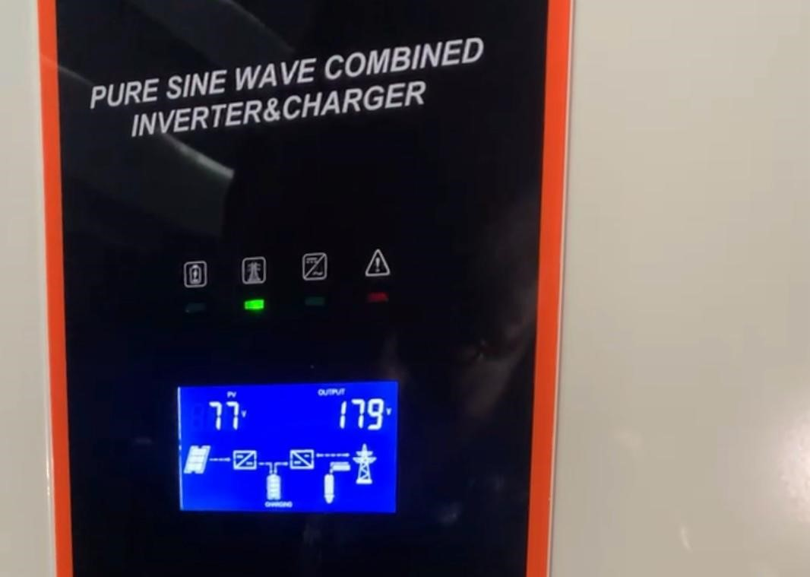
Plate 4.1: Volt from the panel
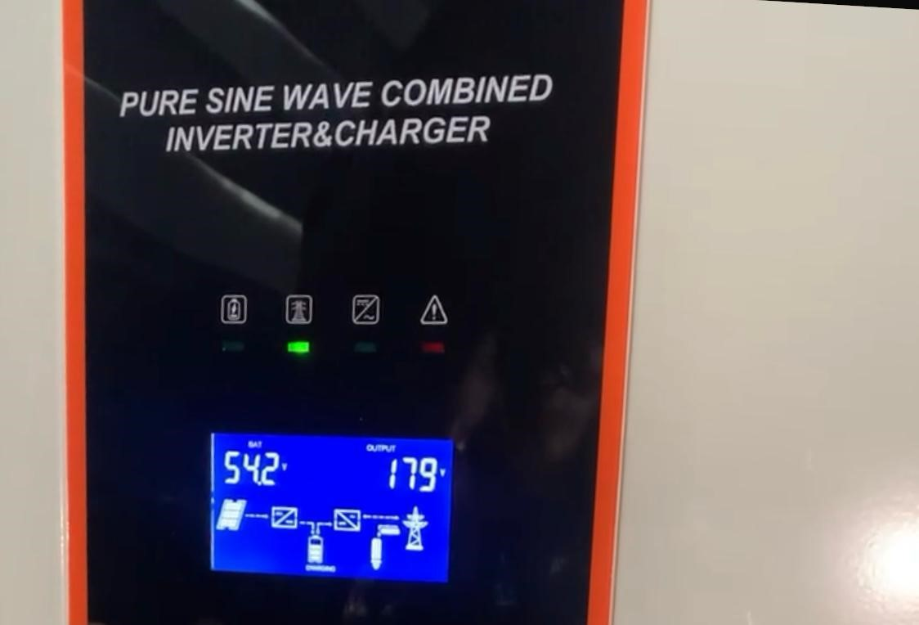
Plate 4.2: Battery health
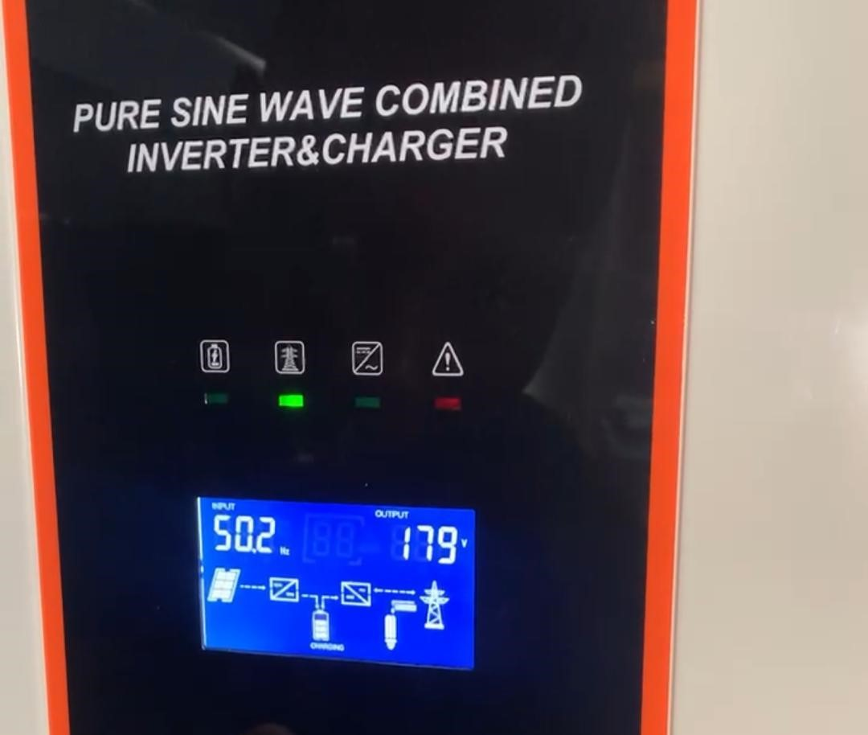
Plate 4.3: Incoming frequency
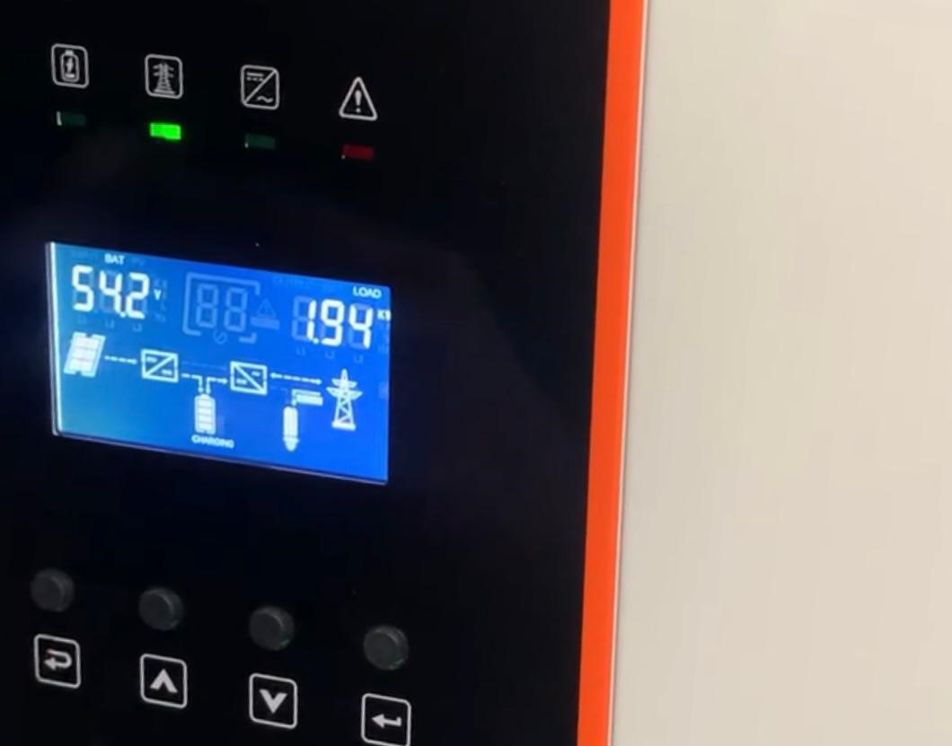
Plate 1.4: Present load

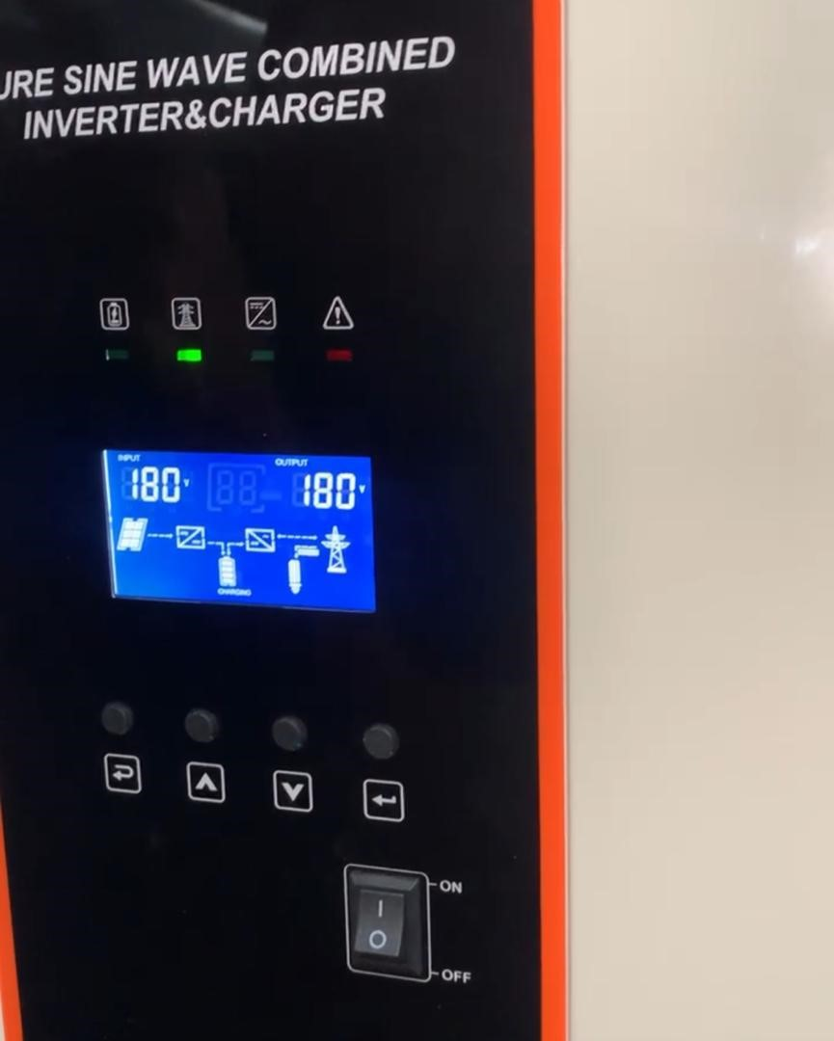
Plate 4.5: Volt coming from the grid

Table 4.1: Parameters Measured During System’s Operation

Parameter Value Unit Observation

Panel Power | 138 | Watts | Significantly below ideal range; possibly due to shading or suboptimal panel angle.
Panel Voltage | 78 | Volts | Adequate voltage for MPPT controller input.
Battery Voltage | 54.2 | Volts | Indicates a nearly full state of charge.
Battery Current | 35 | Amps | Supports current load effectively.
Inverter Output  Frequency | 150.2 | Hertz | Highly abnormal; signals malfunction in oscillator control.
Grid Input Voltage | 220 | Volts | Nominal voltage level; suitable for AC systems.
Load Power | 1900 | Watts | Reflects medium consumption; consistent with household use.
Apparent Power | 1.96 | kVA | Close to real power; suggests efficient energy use.
Load Utilization | 48 | Percent | Suggests system is operating below capacity,
which is good for longevity.

Grid to Inverter 500 ms Fast enough to maintain continuity for most
Switch Delay appliances.
Fault Response 3 seconds Longer than ideal; may affect sensitive electronics. Delay

4.3 System Load Calculation
The inverter system under evaluation was rated for a total output capacity of 4 kW. During testing, the system delivered 1900 watts to connected appliances. The percentage load is calculated as:
𝐿𝑜𝑎𝑑 𝑈𝑡𝑖𝑙𝑖𝑧𝑎𝑡𝑖𝑜𝑛 = 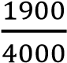 × 100 = 47.5 (4.1)
This value indicates that the inverter operates at less than half of its rated capacity, which is advantageous from a thermal management and reliability standpoint. Operating at lower loads minimizes the heat generated in power electronics, reduces switching stress, and extends the useful life of internal components.

4.4 Battery Discharge Analysis
The inverter draws its power from a battery bank rated for 54.2 volts, supplying a continuous current of 35 amps during operation. The power delivered is computed using:
𝑃 = 𝑉 ∗ 𝐼 = 54.2𝑉 × 35𝐴 = 1897𝑊𝑃 (4.2)
This shows that the battery bank was able to comfortably support the load demand during the test. However, continuous operation at such a discharge level without rest periods could affect the battery's cycle life. This underscores the importance of an intelligent BMS that regulates charging and discharging patterns while monitoring temperature and internal resistance.

4.5 Power Factor Determination
Power factor is a key indicator of electrical efficiency in AC systems. It is calculated as:
𝑅𝑒𝑎𝑙𝑝𝑜𝑤𝑒𝑟 1900
𝑃𝐹 = = = 0.97 (4.3)
𝐴𝑝𝑝𝑎𝑟𝑒𝑛𝑡𝑃𝑜𝑤𝑒𝑟 11960
A power factor of 0.97 is exceptionally good, showing minimal presence of reactive power. This high efficiency minimizes energy waste and improves voltage regulation across connected equipment. Such performance is often a design goal in modern inverter systems and may indicate proper filtering and load balancing by the inverter’s control algorithms.

4.6 Anomalous Inverter Frequency
One of the critical issues observed during the test is the extremely high output frequency of 150.2 Hz instead of the standard 50 Hz. This kind of deviation can severely affect AC loads and implies a malfunction in the inverter’s frequency control mechanism. We infer that a low damping factor results in overshoot and sustained oscillation, which could be the case here. Possible causes include:
i. Faulty phase-locked loop (PLL) ii. Damaged timing crystal in the oscillator iii. Unstable firmware algorithm
Immediate troubleshooting and calibration are required to avoid damage to connected loads.

4.7 Solar Input Behavior
Although the panel voltage of 78V is within acceptable MPPT range, the output power of 138W is far below standard. Ideally, the panel should deliver 250–350W under direct sunlight. The underperformance suggests one or more of the following:
- Dust or dirt on panel surface
- Incorrect panel tilt angle iii. Shading from nearby structures iv. Inefficiencies in the MPPT tracking logic
Improving these physical conditions and verifying software settings can help increase energy harvest and system autonomy.

4.8 System Response Delays
Inverter systems are expected to switch within milliseconds to maintain uninterrupted supply. The 500ms switching delay when transitioning from grid to battery is acceptable and meets most international standards.
However, the 3-second delay during fault conditions is longer than desirable. This delay could be due to: i. Relay switch debounce logic ii. Battery voltage verification checks iii. Thermal throttling before reconnection A first-order delay model illustrates this:
𝑇(𝑠) = 1𝑇𝑠 + 1 𝑤ℎ𝑒𝑟𝑒 𝑇 = 3𝑠 (4.4)
The slow response time can be improved by optimizing the control loop and deploying faster microcontrollers or solid-state relay modules.

4.9 Ratings, Analysis and Calculations
𝐿𝑜𝑎𝑑 𝑠𝑖𝑧𝑖𝑛𝑔 2𝑢𝑛𝑖𝑡 𝐴. 𝑐 = 1000𝑤 𝑎𝑛𝑑 1500𝑤 = 2500𝑤𝑡 (4.5)
1𝑢𝑛𝑖𝑡 𝑇𝑣 = 200𝑤𝑡 (4.6)
1𝑢𝑛𝑖𝑡 𝑓𝑟𝑖𝑑𝑔𝑒 = 300𝑤𝑡 (4.7)
𝑆𝑜𝑐𝑘𝑒𝑡𝑠 𝑜𝑢𝑡 𝑙𝑒𝑡 = 500𝑤𝑡 (4.8)
𝐿𝑖𝑔ℎ𝑡𝑛𝑖𝑛𝑔 𝑝𝑜𝑖𝑛𝑡𝑠 = 200𝑤𝑡 (4.9)
𝑇𝑜𝑡𝑎𝑙 = 3700𝑤𝑡 (4.10)
The power ratings of the appliances that the inverter will power have been used to determine the system's overall electrical load. The following is the breakdown:
i. Two air conditioners with 1000 and 1500watt ratings each add up to 2500 watts ii. One 200-watt television. iii. One refrigerator with a 300-watt rating. iv. socket outlets, which are thought to use about 500 watts overall.
- lighting outlets, totalling 200 watts in rating.
- When all of these are added together, the total power needed is:3700 watts (3.2 kW)
This indicates that when all of the appliances connected to the inverter are running at the same time, 3.2 kilowatts of power will be used. Now, it's critical to comprehend how a 5kVA hybrid inverter works. Rating in relation to the overall load. Kilovolt-ampere, or kVA, is a unit of apparent power. The power factor must be taken into consideration in order to determine the actual usable power (in kilowatts) that a 5kVA inverter can supply. The power factor, which takes into consideration the discrepancy between apparent and real power, is usually approximately 0.8 for the majority of residential loads. Consequently, a 5kVA inverter can provide Real power:
. (4.11)

This indicates that 4,000 watts of load can be supported at any given time by the 5kVA inverter. The inverter is not working at its full capacity because the total connected load is 3,200 watts. This is perfect because it acts as a buffer against unforeseen or additional loads and prevents the inverter from operating at the maximum capacity

4.10 Summary Table
Component | Finding | Suggested Correction
Inverter | Over frequency (150.2  Hz) | Recalibrate oscillator; inspect PLL or DSP firmware
Solar Panel | Underperforming  (138W) | Clean, realign, check MPPT configuration
Battery | Discharging at 35A | Monitor thermal performance; stagger peak loads
Transfer  Switch | Delayed fault recovery  (3s) | Use faster MCU, reduce debounce delay, improve error handling logic

CHAPTER FIVE
CONCLUSION AND RECOMMENDATIONS

5.1 Conclusion
An efficient and long-term way to deal with power instability and lessen reliance on the national grid is to install a 5kVA hybrid solar inverter system. The system was successfully configured to deliver dependable and seamless electricity to vital household appliances through careful load analysis, appropriate system sizing, and the integration of essential components like lithium-ion batteries, surge protection devices, voltage regulators, and a changeover switch. The inverter cleverly controls energy flow to optimize efficiency, and the combination of solar energy and battery storage guarantees a steady power supply even during grid outages. This project not only shows how renewable energy solutions can be used in daily life, but it also emphasizes how crucial intelligent energy management is in areas with unpredictable power supplies. In the end, the system acts as a prototype for affordable, reliable, and clean energy for small businesses and residential uses.

5.2 Recommendations
Recommendations To enhance the functionality, reliability, and scalability of the 5kVA hybrid solar inverter system, the following recommendations are proposed:
- Adopt a regular cleaning and inspection of solar panels to get rid of the dust and debris and ensure full efficiency, and make sure that you check the ground system regularly to make it safe in case of a thunderstorm.
- Add Residual Current Devices (RCDs) in the Distribution Board and a Smart Energy meter in the supply board is to check the real-time consumption of power and avoid possible circuit overloading.
- Add secondary surge protection devices (SPDs) for DC and AC sides and cooling fans in the protection box to safeguard against lightning and overheating.
- Replace the manual changeover knife switch with an automatic transfer switch (ATS) to enable automatic switching between power sources.
- Integrate a Battery Management System (BMS) with remote monitoring, and consider
adding a parallel battery bank to increase runtime under full load.
- Develop a mobile application or web interface for real-time system monitoring and control, paired with user training on operation and troubleshooting.
- Make all outdoor elements have IP65 rating and fulfill the standards set by the Nigerian Electricity Regulatory Commission (NERC), and have smoke detectors and fire
extinguishers located close to other important parts.
- iii. scale up the system to add more panels or batteries and explore net metering on the grid
input, if permitted.
These enhancements will improve the system’s efficiency, safety, and adaptability, ensuring reliable power delivery and integration into modern energy networks.

REFERENCEES
Agarwala, A., Tahsin, T., Ali, Md. F., Sarker, S. K., Abhi, S. H., Das, S. K., Das, P., Hasan, Md., Tasneem, Z., Islam, Md. M., Islam, Md. R., Badal, Md. F. R., and Ahamed, Md. H. (2024).
Aghaei, M., Alahmer, H., Alahmer, A., and Baraldi, P. (2024). Forecasting Solar Photovoltaic Power Production: A Comprehensive Review and Innovative Data-Driven Modeling Framework.
Ahmad, T., Madonski, R., Zhang, D., Huang, C., and Mujeeb, A. (2022a). Data-driven probabilistic machine learning in sustainable smart energy/smart energy systems: Key developments, challenges, and future research opportunities in the context of smart grid paradigm. Renewable and Sustainable Energy Reviews, 160, 112128.

Ahmad, T., Madonski, R., Zhang, D., Huang, C., and Mujeeb, A. (2022b). Data-driven probabilistic machine learning in sustainable smart energy/smart energy systems: Key developments, challenges, and future research opportunities in the context of smart grid paradigm. Renewable and Sustainable Energy Reviews, 160, 112128.
Ahmed, I., Basit, A., E Mustafa, F., Alqahtani, M., and Khalid, M. (2023). The nexus of energy in microgrids: A review on communication barriers in distributed networks auxiliary controls. IET
Ahmed, R., Sreeram, V., Mishra, Y., and Arif, M. D. (2020). A review and evaluation of the stateofthe-art in PV solar power forecasting: Techniques and optimization. Renewable and Sustainable Energy Reviews, 124, 109792.
Al Alahmadi, A. A., Belkhier, Y., Ullah, N., Abeida, H., Soliman, M. S., Khraisat, Y. S. H., and Alharbi, Y. M. (2021). Hybrid wind/PV/battery energy management-based intelligent noninteger control for smart DCmicrogrid of smart university. IEEE Access, 9, 98948–98961.
Albarrak, A. M. (2024). Integration of Cybersecurity, Usability, and Human-Computer Interaction for Securing Energy Management Systems. Sustainability (2071-1050), 16(18).
Al-Dahidi, S., Madhiarasan, M., Al-Ghussain, L., Abubaker, A. M., Ahmad, A. D., Alrbai, M.,
Alhamrouni, I., Abdul Kahar, N. H., Salem, M., Swadi, M., Zahroui, Y., Kadhim, D. J., Mohamed, F. A., and Alhuyi Nazari, M. (2024b). A Comprehensive Review on the Role of Artificial Intelligence in Power System Stability, Control, and Protection: Insights and Future Directions. Applied Sciences, 14(14), 6214.

Allioui, H., and Mourdi, Y. (2023). Exploring the full potentials of IoT for better financial growth and stability: A comprehensive survey. Sensors, 23(19), 8015.
Almannaei, K. J. (2024). Predictive Maintenance on Drone Batteries Failure Using Machine Learning [Master’s Thesis, Rochester Institute of Technology].

Alolaiwy, M., Hawsawi, T., Zohdy, M., Kaur, A., and Louis, S. (2023). Multi-objective routing optimization in electric and flying vehicles: A genetic algorithm perspective. Applied Sciences, 13(18), 10427.
Alotaibi, I., Abido, M. A., Khalid, M., and Savkin, A. V. (2020). A comprehensive review of recent advances in smart grids: A sustainable future with renewable energy resources. Energies, 13(23), 6269.
Al-Shetwi, A. Q. (2022). Sustainable development of renewable energy integrated power sector: Trends, environmental impacts, and recent challenges. Science of The Total Environment, 822, 153645.
Al-Taie, R. R., and Hesselbach, X. (2024). Cost-Effective Power Management for Smart Homes:
Ashok, B., Kannan, C., Mason, B., Ashok, S. D., Indragandhi, V., Patel, D., Wagh, A. S., Jain, A., and Kavitha, C. (2022). Towards safer and smarter design for lithium-ion-battery-powered electric vehicles: A comprehensive review on control strategy architecture of battery management system. Energies, 15(12), 4227.
Badam, R., Murthy, B. R., and Doss, S. (n.d.). Solar Energy Forecasting: Enhancing Reliability and
Bailly, G., Khamassi, M., and Girard, B. (2023). Computational Model of the Transition from
Novice to Expert Interaction Techniques. ACM Transactions on Computer-Human
Interaction, 30(5),
Balog, R. S., and Davoudi, A. (2012). Batteries, Battery Management, and Battery Charging Technology. In A. Elgowainy (Ed.), Electric, Hybrid, and Fuel Cell Vehicles (pp. 315–352).
Banik, R., and Das, P. (2020). A Review on Architecture, Performance and Reliability of Hybrid Power System. Journal of The Institution of Engineers (India): Series B, 101(5), 527–539. https://doi.org/10.1007/s40031-
Barrie, I., Agupugo, C. P., Iguare, H. O., and Folarin, A. (2024). Leveraging machine learning to optimize renewable energy integration in developing economies. Global Journal of Engineering and Technology Advances, 20(03), 080–093.

Basit, M. A., Dilshad, S., Badar, R., and Sami Ur Rehman, S. M. (2020). Limitations, challenges, and solution approaches in grid-connected renewable energy systems. International Journal of Energy Research, 44(6), 4132–4162. https://doi.org/10.1002/er.5033
Bassey, K. E. (2023a). Hybrid renewable energy systems modeling. Engineering Science and Technology Journal, 4(6), 571–588.
Batarseh, I., and Alluhaybi, K. (2020). Emerging opportunities in distributed power electronics and battery integration: Setting the stage for an energy storage revolution. IEEE Power Electronics Magazine, 7(2), 22– 32.
Bathre, M., and Das, P. K. (2023). Smart dual battery management system for expanding lifespan of wireless sensor node. International Journal of Communication Systems, 36(3), e5389.
Bi, S., Yuan, X., Hu, S., Li, K., Ni, W., Hossain, E., and Wang, X. (2024). Failure Analysis in NextGeneration

Bianchi, F., and Riva, E. (2021). Hybrid inverter-transformer systems for efficient renewable energy integration. Journal of Renewable and Sustainable Energy, 13(4), 043301.
Innovative Scheduling Techniques and Integrating Battery Optimization in 6G Networks.
International Journal of Electrical Power and Energy Systems, 98, 76-85. Gao, S., and Li, F. (2022). Intelligent control strategies for hybrid inverters in renewable energy systems. IEEE Transactions on Industrial Electronics, 69(11), 10456-10467.
Lee, J., and Choi, B. (2018). Load balancing techniques for hybrid power systems.
Precision. In Intelligent Systems and Industrial Internet of Things for Sustainable Development (pp. 292–316).

Sustainable Energy Reviews, 167, 112671.
Towards next generation power grid transformer for renewables: Technology review. Engineering Reports, 6(4), e12848. https://doi.org/10.1002/eng2.12848
Xu, L., Wu, F., Chen, R., and Li, L. (2023). Data-driven-aided strategies in battery lifecycle management: Prediction, monitoring, and optimization. Energy Storage Materials, 59, 102785.
Xu, Y., Yan, C., Liu, H., Wang, J., Yang, Z., and Jiang, Y. (2020). Smart energy systems: A critical review on design and operation optimization. Sustainable Cities and Society, 62, 102369.

